TRƯỜNG ĐẠI HỌC GIAO THÔNG VẬN TẢI TP. HỒ CHÍ MINH
VIỆN CÔNG NGHỆ THÔNG TIN VÀ ĐIỆN, ĐIỆN TỬ



NHÓM 4
MACHINE LEARNING PROJECT REPORT

Giảng viên: NGUYỄN THỊ KHÁNH TIÊN

Nhóm thực hiện: Trà Dương Kiến Nguyên
Nguyễn Đức Mạnh
Đặng Phan Hoàng Phát
Nguyễn Thanh Nhân
Lâm Bảo Hoàng Nhật
Hà Yến Nhi
Lê Thị Thu Ngân

Thành phố Hồ Chí Minh, tháng 9 năm 2026

TASK ALLOCATION TABLE
Full Name | Student ID | Task Completion Assessment
Trà Dương Kiến Nguyên | 096206000747 | 100%
Nguyễn Đức Mạnh | 042206013068 | 100%
Nguyễn Thanh Nhân | 080206006904 | 100%
Đặng Phan Hoàng Phát | 079206010472 | 100%
Lâm Bảo Hoàng Nhật | 052206017783 | 100%
Hà Yến Nhi | 083306001680 | 100%
Lê Thị Thu Ngân | 080306008718 | 100%

TABLE OF CONTENTS
ACKNOWLEDGEMENTS 8
Introduction 9
LAB 1: EMAIL SPAM CLASSIFICATION 10
1.1. Introduction 10
1.1.1 Problem Definition 10
1.1.2 Business or Research Context 10
1.1.3 Objectives of the Lab 10
1.1.4 Machine Learning Task Type 10
1.2. Dataset Description and Project Workflow 10
1.2.1 Data Source 10
1.2.2 Dataset Structure 11
1.2.3 Input Features and Target Variable 11
1.2.4 Overview of the Machine Learning Pipeline 11
1.2.5 Tools, Libraries, and Reproducibility 12
1.3. Exploratory Data Analysis and Data Quality Assessment 13
1.3.1 Data Ingestion 13
1.3.2 Data Validation 14
1.3.2.1 Missing Values 14
1.3.2.2 Duplicate Records 17
1.4. Exploratory Data Analysis 21
1.4.1. Email Behavioral Analysis Objectives and Methodology 21
1.4.2. Class Imbalance and Cost Asymmetry Analysis 21
1.4.3 Visual Analytics and Data Profiling 22
1.4.3.1 Average text length – Spam vs. Ham 22
1.4.3.2. Descriptive Statistics & Outlier Thresholds 23
1.4.3.3 Analysis and Extraction of Specific Anomaly Patterns (Anomaly Inspection) 24
1.5. Text Preprocessing 27
1.5.1 Text Cleaning and Pipeline Normalization) 27
1.5.2 Meta-Token Mapping, Rule-Based Filtering, and Vocabulary Reduction Evaluation 28
1.6. Vectorizing Text Using TF-IDF From-Scratch 30
1.6.1. Theoretical Foundations and Mathematical Formulation 30
1.6.2. Hyperparameter Settings and Architectural Constraints 31
1.6.3. Empirical Extraction Results 32
1.7. Stratified Data Split (Stratified Train/Val/Test Split) 32
1.7.1. Splitting Strategy and Class Imbalance Rationale 32
1.7.2. Exact Numerical Partitioning 32
1.8. Three Classification Algorithms from Scratch 33
1.8.1. Overview of Zero-Dependency Architectural Design 33
1.8.2. Multinomial Naive Bayes 33
1.8.3. Logistic Regression 34
1.8.4. Linear Support Vector Machine 35
1.9. Model Evaluation and Result Analysis 36
1.9.1. Evaluation Metrics 36
1.9.2. Candidate Model Comparison on Validation Set 37
1.9.3. Decision Threshold Tuning 38
1.9.4. Final Test Set Evaluation & Cross-Model Benchmark 39
1.9.5. Detailed Error Analysis of Champion Model on Test Set 39
1.9.6. Model Interpretation and Generalization Stability 40
1.10. Deployment, Limitations, and Conclusion 40
1.10.1. Saved Model Artifacts and Reproducibility 40
1.10.2. Limitations and Future Work 41
1.10.3. Final Assessment and Conclusion 42
LAB 2: PRODUCT SALES PREDICTION 42
2.1 Introduction 42
2.1.1 Problem Definition 42
2.1.2 Business or Research Context 42
2.1.3 Objectives of the Lab 42
2.1.4 Machine Learning Task Type 43
2.2 Dataset Description and Project Workflow 43
2.2.1 Data Source 43
2.2.2 Dataset Structure 43
2.2.3 Input Features and Target Variable 44
2.2.4 Overview of the Machine Learning Pipeline 44
2.2.5 Tools, Libraries, and Reproducibility 44
2.3 Exploratory Data Analysis and Data Quality Assessment 45
2.3.1 Data Overview 45
2.3.2 Target Variable Analysis 45
2.3.3 Missing Values and Duplicate Records 45
2.3.4 Distribution Analysis 45
2.3.5 Outlier and Noise Detection 46
2.3.6 Relationship and Pattern Analysis 47
2.4 Data Preprocessing 47
2.4.1 Data Splitting Strategy 47
2.4.2 Data Cleaning 48
2.4.3 Missing Value Handling 48
2.4.4 Invalid, Noisy, and Inconsistent Data Handling 48
2.4.5 Outlier Handling Strategy 48
2.4.6 Encoding, Vectorization, or Image Resizing 48
2.4.7 Feature Scaling and Leakage Control 48
2.5 Feature Engineering and Data Representation 49
2.5.1 Feature Creation 49
2.5.2 Feature Transformation 49
2.5.3 Feature Extraction 49
2.5.4 Feature Encoding or Vectorization 49
2.5.5 Feature Selection or Dimensionality Diagnostics 49
2.6 Model Development 50
2.6.1 Baseline or Initial Model 50
2.6.2 Candidate Algorithms 50
2.6.3 Final Model Selection 51
2.6.4 Core Idea of the Selected Algorithm 51
2.6.5 Implementation Design 51
2.6.6 Hyperparameter Tuning or Model Selection Strategy 51
2.7 Model Evaluation and Result Analysis 52
2.7.1 Evaluation Metrics 52
2.7.2 Quantitative Results 52
2.7.3 Model Comparison 53
2.7.4 Error Analysis 53
2.7.5 Model Interpretation 53
2.7.6 Robustness, Stability, or Generalization Analysis 54
2.8 Deployment, Artifacts, and Reproducibility 55
2.8.1 Saved Models and Pipelines 55
2.8.2 Inference Procedure 55
2.8.3 Output Files and Visualizations 55
2.8.4 Reproducibility Settings 55
2.8.5 Practical Deployment Considerations 56
2.9 Limitations and Future Work 56
2.9.1 Main Limitations 56
2.9.2 Possible Improvements 56
2.9.3 Future Research Directions 57
2.10 Conclusion 57
2.10.1 Summary of Key Findings 57
2.10.2 Final Model Assessment 57
LAB 3: CUSTOMER SEGMENTATION 57
3.1. Introduction 57
3.1.1 Problem Definition 57
3.1.2 Business Context 58
3.1.4 Machine Learning Task Type 58
3.2. Dataset Description and Project Workflow 59
3.2.1 Data Source 59
3.2.2 Dataset Structure 59
3.2.3 Data Utilization Strategy 59
3.2.4 The 13-Stage Custom Engineering Pipeline 60
3.2.5 Tools, Frameworks, and Academic Constraints 60
3.3. Exploratory Data Analysis and Data Quality Assessment 61
3.3.1 Structural Data Validation and Integrity Audit 61
3.3.2 Customer Demographic Analysis 61
3.3.3 Descriptive Statistics of Numerical Features 62
3.3.4 Income and Spending Behavior Analysis 62
3.3.5 Outlier Diagnostics and Correlation Analysis 63
3.4. Data Preprocessing and Feature Engineering 64
3.4.1 Data Cleaning and Feature Selection Rationale 64
3.4.2 Custom Z-Score Normalization from Scratch 64
3.4.3 Parameter Isolation for Future Inference (No-Fit Protocol) 65
3.5. Custom K-Means Core Algorithm Construction 65
3.5.1 Vectorized Euclidean Distance Matrix via Broadcasting 65
3.5.2 Advanced Centroid Initialization via K-Means++ 65
3.5.3 Iterative Lloyd's Loop, Convergence Criterion, and Empty Cluster Safeguard 66
3.6. Optimal K Determination and Clustering Evaluation 66
3.6.1 The Elbow Method and WCSS Trajectory 66
3.6.2 Silhouette Coefficient Formulation 66
3.6.3 Final K = 5 Selection Diagnostic 67
3.7. Final Model Execution and 2D Spatial Interpretation 68
3.7.1 Final Model Configuration and Convergence Dynamics 68
3.7.2 2D Spatial Scatter Visualization 68
3.8. Customer Personas Identification and Actionable Retail Strategy 69
3.8.1 Comprehensive Persona Profiling 69
3.8.2 Granular Persona Profiles and Actionable Marketing Roadmaps 70
3.9. Model Serialization and Production Inference Pipeline 71
3.9.1 Architectural Rationale for JSON Model Artifact 71
3.9.2 Production Inference Workflow and Empirical Verification 71
3.10. Limitations and Future Work 72
3.10.1 Technical and Methodological Limitations 72
3.10.2 Future Research and Engineering Enhancements 72
3.11. Project Conclusion and Key Takeaways 72
3.11.1 Summary of Key Achievements 72
3.11.2 Final Assessment 73
LAB 4: HOUSE PRICE PREDICTION 73
4.1. Introduction 73
4.1.1. Problem Definition 73
4.1.2 Business and Research Context 73
4.1.3 Objectives of the Lab 74
4.1.4 Machine Learning Task Type 74
4.2 Dataset Description and Project Workflow 74
4.2.1 Data Source 74
4.2.2 Dataset Structure 75
4.2.3 Input Features and Target Variable 75
4.2.4 Overview of the Machine Learning Pipeline 75
4.2.5 Tools, Libraries, and Reproducibility 75
4.3 Exploratory Data Analysis and Data Quality Assessment 76
4.3.1 Data Overview 76
4.3.2 Target Variable Analysis 76
4.3.3 Missing Values and Duplicate Records 76
4.3.4 Distribution Analysis 77
4.3.5 Outlier and Noise Detection 78
4.3.6 Relationship and Pattern Analysis 79
4.4 Data Splitting and Data Preprocessing 80
4.4.1 Early Data Splitting Strategy 80
4.4.2 Data Cleaning 80
4.4.3 Missing Value Handling 81
4.4.4 Invalid, Noisy, and Inconsistent Data Handling 81
4.4.5 Outlier Handling Strategy 81
4.4.6 Categorical Feature Encoding 81
4.4.7 Feature Scaling and Leakage Control 82
4.5 Feature Engineering and Data Representation 82
4.5.1 Feature Creation 82
4.5.2 Target Transformation 82
4.5.3 Feature Transformation 83
4.5.4 Feature Encoding and Data Representation 83
4.5.5 Feature Selection Strategy 83
4.5.6 Post-Preprocessing Audit 83
4.5.7 PCA Diagnostic and Dimensionality Analysis 83
4.6 MLP Model Development 83
4.6.1 Baseline and Candidate Models 83
4.6.2 Primary Model: MLP Regression 83
4.6.3 Core Idea of MLP Regression 83
4.6.4 Network Architecture 84
4.6.5 PyTorch Dataset and DataLoader 84
4.6.6 Training Configuration 84
4.6.7 Training and Optimization Process 85
4.6.8 Early Stopping and Checkpoint Selection 85
4.6.9 Model Selection Strategy 85
4.7 Model Evaluation and Result Analysis 85
4.7.1 Evaluation Metrics 85
4.7.2 Quantitative Results 86
4.7.3 Prediction Visualization 87
4.7.4 Model Comparison 89
4.7.5 Error Analysis 90
4.7.6 Model Interpretation 91
4.7.7 Training Stability and Overfitting Analysis 91
4.7.8 Generalization and External Stress Test 91
4.8 Model Artifacts, Inference, and Deployment 91
4.8.1 Saved Model and Pipeline 91
4.8.2 Inference Procedure 91
4.8.3 Output Files and Visualizations 91
4.8.4 Reproducibility Settings 91
4.8.5 Practical Deployment Considerations 92
4.9 Limitations and Future Work 92
4.9.1 Main Limitations 92
4.9.2 Possible Improvements 92
4.9.3 Future Research Directions 92
4.10 Conclusion 92
4.10.1 Summary of Key Findings 92
4.10.2 Final Model Assessment 92

ACKNOWLEDGEMENTS
First of all, our group would like to express our sincere gratitude and deepest appreciation to PhD. Nguyen Thi Khanh Tien for her dedicated teaching, valuable guidance, and enthusiastic support throughout the Machine Learning course and the preparation of this report. Her clear, engaging, and well-structured lectures provided us with a profound understanding of both the theoretical foundations and practical applications of machine learning. Throughout the course, we had the invaluable opportunity to explore essential concepts, including data analysis, data preprocessing, feature extraction, model development, training, and performance evaluation.
We are especially grateful for her patience, constructive feedback, and the opportunities to practice through various projects. This hands-on approach not only reinforced our technical knowledge but also significantly improved our analytical thinking, problem-solving abilities, teamwork, and scientific presentation skills. Her dedicated guidance played an essential role in helping us refine our work and complete this report effectively.
Although our group made every effort to complete this report to the best of our ability, we acknowledge that our knowledge and experience are still limited, and certain shortcomings are unavoidable. We sincerely welcome her valuable comments and recommendations so that we may learn from this experience and continue to improve in our future academic endeavors.
Once again, we extend our heartfelt gratitude and profound respect to PhD. Nguyen Thi Khanh Tien. We sincerely wish her continued health, happiness, and success in her teaching and professional career.

Introduction
In today's digital era, data has become an increasingly vital resource across virtually every domain, spanning economics, finance, healthcare, e-commerce, telecommunications, and modern cybersecurity. The ability to systematically analyze, extract patterns, and leverage massive data streams enables organizations to automate complex workflows, make informed strategic decisions, and engineer intelligent systems that directly address real-world operational challenges.
Machine Learning (ML), a core branch of Artificial Intelligence, empowers computational systems to learn inductively from empirical data, discover hidden regularities, and generate reliable predictive inferences without relying on rigid, hand-crafted heuristics. Throughout this course, foundational concepts—including data quality auditing, feature engineering, mathematical vectorization, training dynamics, leakage-safe partitioning, and multidimensional performance evaluation—were explored both theoretically and practically. Mastering these principles establishes a rigorous methodology for architecting reliable machine learning solutions across diverse modalities and industry domains.
This project report synthesizes the practical investigations, algorithmic implementations, and empirical findings conducted across the Machine Learning curriculum. The included laboratories encompass an end-to-end continuum of fundamental machine learning tasks, moving systematically from raw exploratory data analysis and data cleaning to model optimization, hyperparameter tuning, and diagnostic evaluation.
The report is structured into four primary sections:
- Part 1: Email Spam Classification
Focuses on the cybersecurity problem of binary text classification, separating legitimate corporate correspondence from unsolicited spam. The pipeline emphasizes strict transparency by implementing algorithms from scratch, covering custom TF-IDF vectorization, stratified partitioning, Complement/Multinomial Naive Bayes, Logistic Regression, Linear Support Vector Machines (SVM), and decision threshold tuning to protect legitimate communications from false alarms.
- Part 2: Sales Forecasting
Investigates predictive modeling on transaction records to forecast future commercial demand. This section examines data cleaning, aggregation across temporal panels, lag-feature extraction, multivariate regression modeling, and error minimization using standard regression evaluation metrics.
- Part 3: Customer Segmentation
Explores an unsupervised learning framework aimed at grouping customers based on behavioral, transactional, and demographic similarities. Utilizing clustering techniques such as K-Means, dimensionality reduction, and silhouette validation, this section uncovers distinct customer personas to support data-driven marketing decisions.
- Part 4: Boston Housing Price Prediction
Addresses continuous real estate valuation using structured hedonic housing data. This section applies regression architectures, regularization techniques, and rigorous residual analysis to capture multi-attribute dependencies and accurately estimate housing market values.

LAB 1: EMAIL SPAM CLASSIFICATION

1.1. Introduction

1.1.1 Problem Definition
In the field of Machine Learning, detecting spam emails remains a crucial text classification challenge. Spam often encompasses phishing attempts, deceptive advertisements, and malicious content. The primary aim of this lab is to construct a model capable of analyzing textual content to accurately categorize emails as either "spam" (malicious/junk) or "ham" (legitimate).

1.1.2 Business or Research Context
Robust spam filtering is a foundational feature for communication platforms, email clients, and cybersecurity frameworks. Implementing an efficient detection system mitigates potential security risks, minimizes inbox clutter, and enhances overall productivity. In terms of Data Science, this project highlights the practical application of Machine Learning techniques on unstructured text data.

1.1.3 Objectives of the Lab
This assignment requires you to perform raw email data cleaning and preprocessing, followed by the extraction of relevant text-based features. You will train, compare, and evaluate two specific models: Complement Naive Bayes and Linear Support Vector Machine (SVM). Furthermore, the lab involves threshold tuning and feature selection. The final evaluation must include a comprehensive analysis using the confusion matrix, accuracy, precision, recall, F1-score, ROC-AUC, and PR-AUC.

1.1.4 Machine Learning Task Type
Since the dataset consists of pre-labeled emails, this falls under Supervised Learning. Specifically, it is a binary text classification problem, as the output must fall into one of two distinct categories: spam or ham.

1.2. Dataset Description and Project Workflow

1.2.1 Data Source
The data we use in the lab is from the original Kaggle source: https://www.kaggle.com/datasets/jackksoncsie/spam-email-dataset
This dataset contains a collection of email text messages, labeled as either spam or not spam. Each email message is associated with a binary label, where "1" indicates that the email is spam, and "0" indicates that it is not spam. The dataset is intended for use in training and evaluating spam email classification models.

1.2.2 Dataset Structure
The dataset structure consists of 5,728 rows and 2 columns, including:
- text (Text): This column contains the text content of the email messages. It includes the body of the emails along with any associated subject lines or headers.
- spam_or_not (Binary):This column contains binary labels to indicate whether an email is spam or not. "1" represents spam, while "0" represents not spam.
All rows and columns are used for the training model pipeline.

1.2.3 Input Features and Target Variable
The raw text of email communications serves as the primary input feature for this exercise. By analyzing the content, the algorithm identifies underlying patterns, evaluating text signals like spam-associated terms, URLs, digits, and overall word composition. The predicted outcome, or target variable, is the email's classification. For computational purposes in the final stage, the labels are converted into binary values:
- Ham (normal emails): 0
- Spam (unwanted or suspicious emails): 1
The overarching goal of the model is to successfully predict whether unseen email messages belong to the ham or spam class

1.2.4 Overview of the Machine Learning Pipeline
Strict Constraints: The entire pipeline is programmed manually from scratch using fundamental linear algebra and numpy, strictly forbidding high-level machine learning libraries like scikit-learn
Core Architecture: The workflow follows a rigorous sequence:
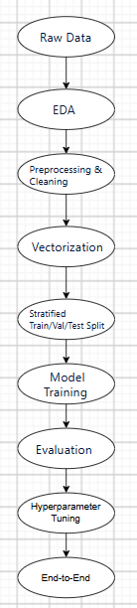

Data Splitting: To accommodate the imbalanced nature of the dataset, a Stratified Split is mandatory to maintain class distribution across splits. The standard ratio applied is 70% Train, 15% Validation, and 15% Test.
Leakage Prevention: A critical rule in the pipeline is that the TF-IDF vocabulary and IDF weights are explicitly fitted only on the training data before being used to transform the validation and test sets, preventing data leakage.

1.2.5 Tools, Libraries, and Reproducibility
a. Development Tools and Libraries The project is implemented on the Windows 11 operating system environment using the Antigravity IDE coding assistant. Regarding the programming language and libraries, the project strictly adheres to the constraints of a "from-scratch" implementation:
- Core Libraries: All mathematical formulas, linear algebra operations, and optimization algorithms are manually programmed in Python, utilizing only the NumPy library.
- Restricted Libraries: High-level Machine Learning libraries (such as scikit-learn) are strictly prohibited from being used for model building or feature preprocessing steps.
- Model Persistence: The project uses Python's standard pickle library for serialization (.pkl format), which allows saving and reloading model parameters and weights after successful training.
b. Ensuring Reproducibility
To ensure that experimental results can be accurately reproduced by other researchers, the project applies the following technical standards:
- Project Architecture Organization: The source code is systematically organized following standard Data Science project structures, isolating modules into specific directories: data (data/), preprocessing and training source code (src/), and model storage (models/). The entire dependency environment is consistently managed through a virtual environment (.venv) and a requirements.txt file, combined with Git/GitHub for version control.
- Strict Data Splitting Mechanism: The Stratified Split technique is applied to partition the dataset according to standard ratios (such as 80/20 or 70/15/15). This ensures that the proportional distribution between the Spam and Ham classes is consistently maintained across the Training, Validation, and Testing sets.
- Preventing Data Leakage: This is a core principle during the preprocessing stage. The process of building the vocabulary and calculating TF-IDF weights (via the .fit() method) is exclusively performed on the training set. The validation and test sets are only transformed (.transform()) based on the vector space learned from the training data, thereby ensuring the model has no prior exposure to the testing data.

1.3. Exploratory Data Analysis and Data Quality Assessment

1.3.1 Data Ingestion
Rationale: The initial step involves loading the raw emails.csv dataset into a structural format (such as a pandas DataFrame). This is a crucial prerequisite for establishing a foundational understanding of the dataset's volume, schema (column structure), and the raw format of the text data prior to implementing any preprocessing algorithms.
Subsequent Steps: The ingested dataset serves as the baseline input for the subsequent Data Quality Assessment and Validation phases, where noise, duplicates, and missing values will be addressed.
Expected Outcome: The successful extraction and loading of over 5,700 email records containing two primary attributes: text (representing the raw email content) and spam (the binary classification label, where 0 indicates legitimate mail and 1 indicates spam).
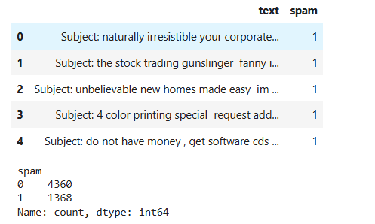

Figure 1.1: Raw data ingestion results and Spam/Ham label distribution.
The upper section of the image displays a preview of the initial rows within the DataFrame, confirming the expected two-column structure (text and spam). It also reveals that the raw text data frequently includes the "Subject:" header. The lower section of the image provides a preliminary frequency count of the target variable (spam). This output confirms a total of 5,728 records, distributed unevenly between 4,360 legitimate emails (class 0) and 1,368 spam emails (class 1), which immediately highlights a class imbalance that must be accounted for during the model training phase.

1.3.2 Data Validation

1.3.2.1 Missing Values
Missing values (often displayed as NaN, Null, or blank cells) are data fields that lack a value due to user input errors, system extraction failures, or the inherent non-existence of the information. Their presence not only biases statistical results but also causes severe technical errors, particularly with text data. Specifically, programming libraries like Pandas treat NaN as a floating-point number (float) by default. Consequently, when executing string operations, the program will throw a data error (AttributeError) and disrupt the entire system. In Machine Learning and Natural Language Processing (NLP), when performing text vectorization (such as TF-IDF or Word2Vec), empty cells will generate undefined matrices, breaking the linear algebraic structure and rendering the algorithm unable to train.
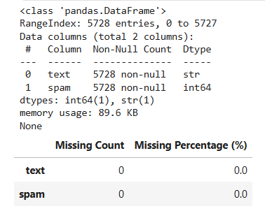
Figure 1.2: System-Level Standard Missing Value Check.
This execution step serves as an initial diagnostic for the dataset. The core objective is to leverage the isnull().sum() function to perform a comprehensive audit across the system for any missing values. More importantly, this process calculates the percentage of missing data relative to the total dataset volume—a quantitative metric essential for evaluating the severity and impact of data incompleteness. Based on this severity level (whether minor or extensive, localized or widespread), analysts gain a solid empirical foundation to determine the appropriate remediation strategy (e.g., row deletion for low missing rates, imputation for moderate missingness, or complete feature removal for excessively high rates).
- Structural Overview (df.info): The dataset contains exactly 5,728 rows (indexed from 0 to 5,727) and 2 columns (text of string/object type, and spam of integer type). Both columns feature 5,728 non-null values. Memory usage is highly optimized at just 89.6 KB.
- Missing Value Analysis (missing_df table): For both attributes (text and spam), the absolute missing count returns 0, resulting in a missing percentage of 0.0%.
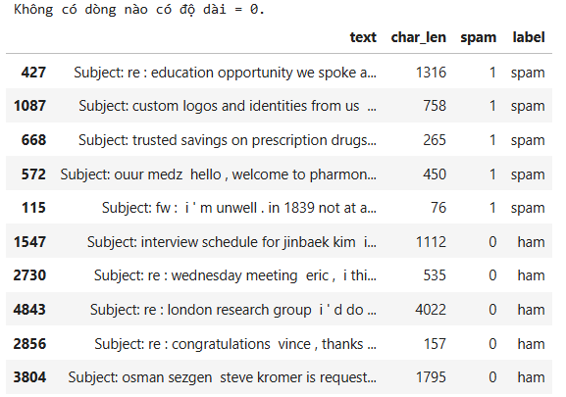
Figure 1.3: Text Character Length Verification.
Following NaN verification, email lengths are analyzed to compare character density between Spam and Ham classes and detect potential outliers. The system confirms the dataset is completely clean and free of empty records (0 characters). Structurally, the text column stores the raw email content, char_len records the character count for distribution visualization, and spam/label serves as the target binary classification (1: Spam, 0: Ham).
Spam Class Distribution (Index 427, 1087, 668, 572, 115): Character lengths range from 76 characters (the shortest - Index 115) to 1,316 characters (the longest - Index 427). These samples indicate that spam emails tend to be moderate in length and concise in order to immediately deliver links or promotional messages.
Ham Class Distribution (Index 1547, 2730, 4843, 2856, 3804): Character lengths range from 157 characters (Index 2856) to 4,022 characters (Index 4843). The distribution range for the Ham class is significantly broader, accurately reflecting the real-world scenario where work exchanges and discussion emails often contain a massive volume of information.
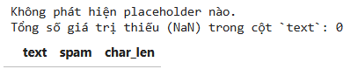
Figure 1.4: Hidden Missing Value Detection and Standardization.
This in-depth inspection aims to eliminate the risk of hidden missing values (such as whitespaces, empty strings, or placeholder keywords like 'NA', 'NULL', 'None') that basic functions like isnull() fail to detect. By scanning the entire text column against a list of suspicious keywords and standardizing them to the pd.NA format, the system re-evaluates the dataset. The results indicate that no placeholders were found; the total missing count after the review remains 0, and the error preview table is entirely empty. This provides absolute confirmation that the dataset is completely clean and free of any disguised missing values.

1.3.2.2 Duplicate Records
a) Following the missing data treatment step, the pipeline proceeds to verify the existence of duplicate records. The presence of emails with completely identical content can cause Data Bias in the Machine Learning model due to repeatedly learning the same weights. Additionally, it introduces a potential risk of Data Leakage if the exact same text sample appears in both the Train and Test sets.
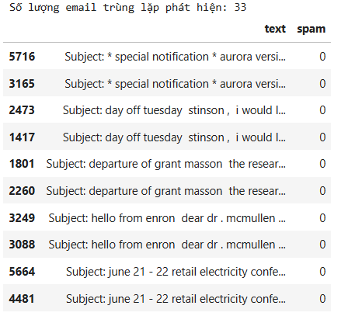
Figure 1.5:
Detection Count: The system scanned the entire dataset and detected exactly 33 emails with duplicate content.The preview table lists the paired duplicate rows possessing identical text content and classification labels (spam). For example: rows 5716 and 3165 both contain the notification Subject: * special notification * aurora versi...; rows 2473 and 1417 both share the time-off request Subject: day off tuesday stinson.... The detected duplicate samples all belong to the legitimate email class (spam = 0).
Following duplicate detection, the pipeline inspects for label conflicts—instances where identical text content is assigned contradictory classification labels (e.g., one row labeled as Spam, another as Ham). This represents a critical anomaly in supervised learning; feeding identical inputs with conflicting outputs disrupts the model's weight optimization process, directly degrading both predictive accuracy and training stability
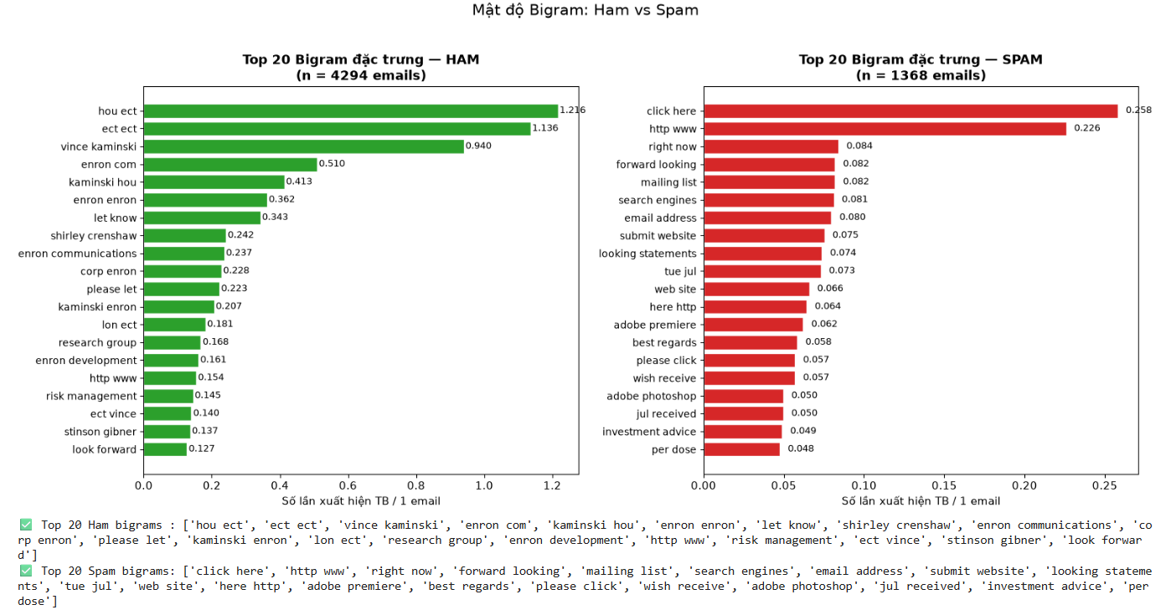
Figure 1.6: Bigram Density: Ham vs Spam
The "Bigram Density: Ham vs Spam" chart compares the top 20 most frequent bigrams (Y-axis) across both classes. Crucially, the X-axis plots the "Average occurrences per email." This rigorous normalization step—scaling raw bigram frequencies by the total number of emails in each respective class—effectively eliminates statistical bias caused by the dataset's inherent class imbalance (4,294 Ham versus 1,368 Spam emails), ensuring a scientifically valid comparison.
Ham Class Bigram Profile (n = 4,294emails) :Representing standard internal communications, the Ham class bigram profile is characterized by three distinct linguistic patterns: corporate identifiers, interpersonal exchanges, and professional vernacular. The text is heavily dominated by dataset-specific domain suffixes and department codes (e.g., hou ect at 1.216 occurrences/email; enron com at 0.510), alongside specific employee names (e.g., vince kaminski [0.940]; shirley crenshaw [0.242]) that highlight direct personnel interactions. Furthermore, the widespread prevalence of collaborative phrases—such as let know (0.343) and look forward (0.127)—reinforces the polite, routine nature of standard corporate correspondence.
Spam Class Bigram Profile (n = 1,368 emails): Representing promotional, deceptive, or marketing communications, the Spam class bigram profile clearly reflects the core tactics of unsolicited email through aggressive call-to-action (CTA) triggers and commercial indicators. The vocabulary is heavily dominated by link redirection and urgency cues, led by click here (0.258 occurrences/email) and http www (0.226), supported by action-oriented phrases such as right now (0.084) and please click (0.057). Additionally, the feature set exhibits strong clustering around digital marketing, software, financial, and pharmaceutical domains, including mailing list (0.082), search engines (0.081), adobe premiere (0.062), investment advice (0.049), and per dose (0.048).
b) To maintain a fair evaluation across subsets with significant sample size disparities (n = 4,294 Ham,n = 1,368 Spam, n = 66 Duplicates), the comparative visualization utilizes the normalized "Average Density per Email" metric on the Y-axis. The analysis is structured around two distinct baselines: Chart 1 references the Top 20 Bigrams of the Ham class, whereas Chart 2 references the Top 20 Bigrams of the Spam class. Visual differentiation is maintained through a consistent color-coding scheme: Green for Ham, Red for Spam, and Orange for Duplicate records.
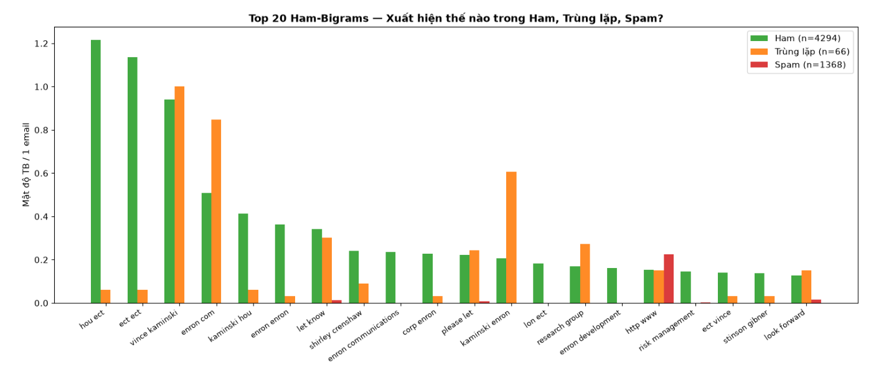
Figure 1.7: Top 20 Ham Bigrams: Distribution across Ham, Duplicate, and Spam Classes
Evaluating the 66 duplicate records against the Ham baseline demonstrates near-total linguistic alignment with internal corporate correspondence. Quantitatively, the duplicate subset (orange bars) mirrors and occasionally surpasses standard Ham densities across key organizational identifiers, such as vince kaminski (1.000 vs. 0.940 occurrences/email), enron com (0.850 vs. 0.510), kaminski enron (0.605 vs. 0.207), and research group (0.275 vs. 0.168). Conversely, Spam occurrences (red bars) remain at zero across 19 of the 20 features, with http www (0.226) being the sole exception. This strong statistical correlation confirms that duplicate entries consist overwhelmingly of legitimate corporate emails—likely stemming from internal broadcast announcements, forward/reply chains, or automated system logging redundancies.
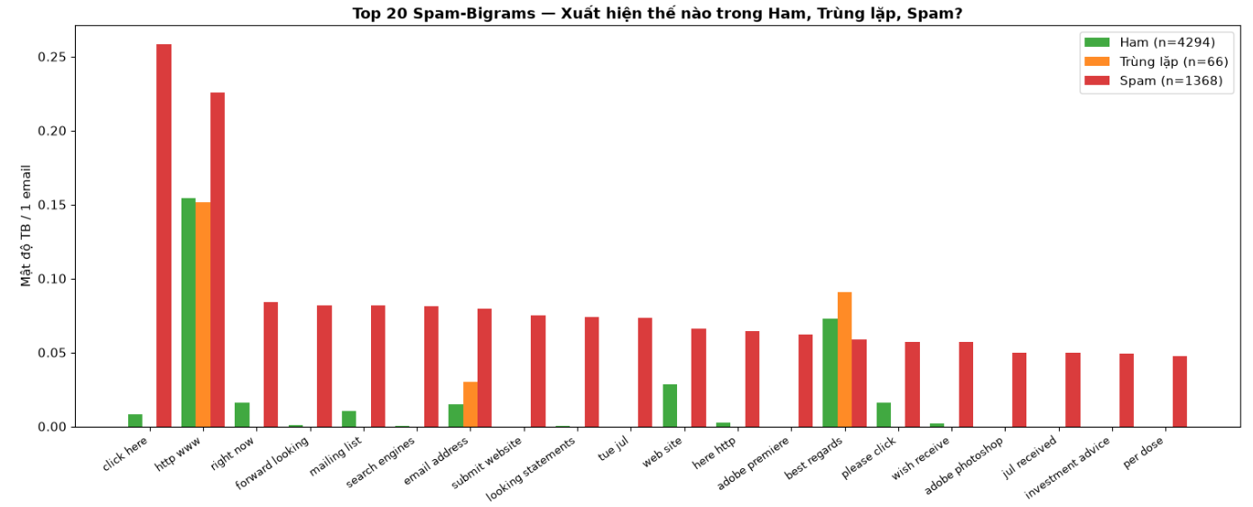
Figure 1.8:Top 20 Spam Bigrams: Distribution across Spam, Duplicate, and Ham Classes
Evaluating the 66 duplicate records against the Spam vocabulary baseline confirms their complete lack of deceptive or promotional characteristics. Quantitatively, while the Spam class (red bars) dominates promotional and Call-to-Action features—such as click here (0.258 occurrences/email), http www (0.226), right now (0.084), and mailing list (0.082)—the duplicate subset (orange bars) is entirely absent across all signature spam terms. Duplicate instances register only within neutral, generic tokens like http www (0.152 vs. Ham's 0.154) and best regards (0.091 vs. Ham's 0.073). This statistical absence of commercial indicators conclusively verifies that the 66 duplicate records carry virtually no structural signatures typical of spam.
c) Following the bigram density anomalies, raw text was extracted from duplicate records to verify their semantic nature and determine the proper cleaning methodology. Cross-verification identified 33 unique email texts across 66 rows (each duplicated exactly once), with 100% of the instances belonging to the Ham class (0% Spam). Manual text evaluation confirms these records represent authentic internal corporate communications from the Enron corpus, spanning three primary operational areas:
- HR & Administration: Personal leave requests, departure announcements, and interview scheduling.
- Academic & Recruitment: University correspondence, intern evaluation scores, and applicant tracking.
- Operations & Management: Management headcount metrics, departmental budget allocations, and internal software updates (e.g., Aurora).
Two raw text excerpts illustrate the routine corporate character of the duplicate entries:
- Administrative Communication (Email #2): Subject: day off tuesday — "stinson, i would like to take a day off tomorrow ( tuesday , april 10 ) . i need to register my son to elementary school and send my cars to service..." This text represents a standard personal leave request sent directly to a manager or colleague.
- Operational & Budget Allocation (Email #25): Subject: research allocations to egm — "hi becky , vince and i came up with these allocations for all of egm : gary hickerson rate & currency trading 10 . 0 %... total 100 %" This email contains internal financial metrics detailing resource and portfolio distribution across organizational trading units.

1.4. Exploratory Data Analysis

1.4.1. Email Behavioral Analysis Objectives and Methodology
Exploratory Data Analysis (EDA) decodes the statistical characteristics, behavioral patterns, and semantic differences separating legitimate communications (Ham) from unsolicited entries (Spam), establishing the empirical rationale for subsequent engineering decisions:
- Class Imbalance Mitigation: The 76.0% Ham to 24.0% Spam distribution mirrors real-world email streams. To prevent the Accuracy Paradox—where a zero-rule majority classifier yields 76.0% accuracy with 0% Spam Recall—model optimization must rely on Precision, Recall, and F1-Score. Practically, this imbalance mandates Stratified Train-Test Splitting to prevent distribution drift and justifies probability decision threshold tuning.
- Structural Length Profiling: Histogram and boxplot evaluations reveal contrasting drafting strategies. Spam exhibits a bimodal distribution (either hyper-short link drops to evade keyword filters or excessively long "text-stuffed" entries), while Ham shows a unimodal, stable length distribution. Measuring these distribution bounds provides concrete thresholds for text truncation, padding, and short-sample noise filtering during vectorization.
- Contextual Bigram Extraction: Analyzing contiguous two-word sequences captures local syntactic context missed by unigrams alone. Clear class boundaries emerge between commercial triggers in Spam (click here, special offer) and corporate identifiers in Ham (vince kaminski, let know). These semantic profiles empirically justify configuring the TF-IDF vectorizer with ngram_range=(1, 2) to optimize classification boundaries.

1.4.2. Class Imbalance and Cost Asymmetry Analysis
The dataset exhibits a distinct class imbalance, comprising 4,327 Ham instances (76.0%) and 1,368 Spam instances (24.0%), yielding a ratio of approximately 3.16:1. This skew reflects real-world corporate email streams but exposes model evaluation to the Accuracy Paradox: a zero-rule naive classifier predicting every email as Ham would achieve a misleading 76.0% overall accuracy while failing entirely to intercept malicious emails (0% Spam Recall). Consequently, Accuracy is rejected as a standalone performance metric in favor of Spam-specific Precision, Recall, F1-Score, and Confusion Matrix evaluations.
Furthermore, operational deployment reveals a severe misclassification cost asymmetry:
- False Positives (FP): Legitimate emails (e.g., contracts or administrative notices) misclassified as Spam present a critical risk, leading to high operational disruption and lost communications.
- False Negatives (FN): Spam emails slipping into the Inbox impose negligible damage, requiring only manual deletion by the user.
Because protecting legitimate communications is paramount, technical strategy prioritizes maximizing Spam Precision (target >97%) to suppress FP rates. This objective dictates the execution of Stratified Train-Test Splitting to maintain stable 76/24 class proportions across partitions, combined with decision threshold tuning (increasing the Spam classification boundary above 0.5) to strictly minimize false alarms.

1.4.3 Visual Analytics and Data Profiling

1.4.3.1 Average text length – Spam vs. Ham
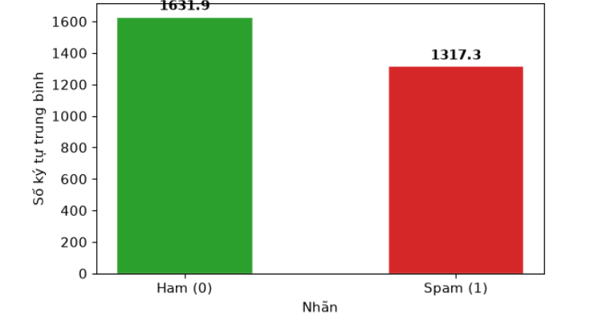
Figure 1.9: Average Text Length: Spam vs. Ham
Comparative evaluation of character length reveals distinct structural behaviors between email classes. Visually encoded via green and red bar indicators, Ham emails average 1,631.9 characters compared to Spam's 1,317.3 characters—a relative difference of 23.89% (314.6 characters). Notably, mean values for both Ham and Spam far exceed their respective medians (= 1,122.0 ; = 693.5), confirming that both length distributions are heavily right-skewed due to extreme outliers.
Behaviorally, Ham emails exhibit greater length because corporate exchanges (Enron corpus) frequently retain complete forward/reply history chains, personal signature blocks, and legal disclaimers. Conversely, Spam emails optimize for brevity to deliver immediate Call-To-Action (CTA) triggers and evade crude keyword filters. While this length disparity provides a valuable discriminative signal, the significant distribution overlap prevents text length from serving as a standalone classifier. Instead, these metrics establish an empirical truncation bound ( 3,972 characters based on Q_3 + 1.5 x IQR), retaining full semantic context for over 93.5%of records while optimizing memory efficiency during TF-IDF vectorization.

1.4.3.2. Descriptive Statistics & Outlier Thresholds
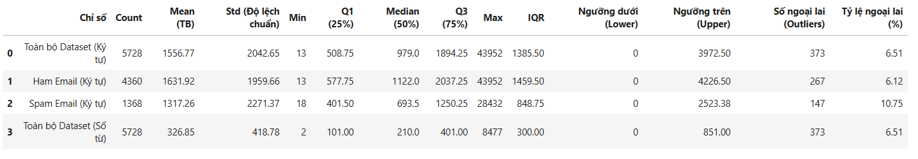
Figure 1.10: Descriptive Statistics and Outlier Thresholds Summary Table
A rigorous descriptive evaluation (n = 5,728) demonstrates that text length distributions across both classes are heavily right-skewed, as parametric arithmetic means significantly exceed non-parametric medians. For character length, the complete dataset yields a mean of 1,556.77 (Median = 979.00, Max = 43,952). Ham instances maintain a longer overall composition averaging 1,631.92 characters (Median = 1,122.00, IQR = 1,459.50) compared to Spam at 1,317.26 characters (Median = 693.50 , IQR = 848.75). However, Spam exhibits substantially higher variance (Std = 2,271.37) and a markedly higher upper-bound outlier density (10.75% vs. Ham's $6.12%), illustrating a dual spam strategy that combines hyper-short link drops with text-stuffed campaigns designed to dilute frequency-based algorithms. Word count distributions align identically, reflecting an overall outlier proportion of 6.51%(373instances).
Because parametric metrics are distorted by extreme maximums (Max = 43,952 characters / 8,477 words), median values and Interquartile Ranges (IQR = Q_3 - Q_1) serve as the definitive measures of central tendency and dispersion. Establishing upper outlier boundaries via non-parametric criteria (Q_3+1.5x IQR) identifies empirical cutoff thresholds at 3,972.50characters ( 851 words). This upper bound provides a mathematical justification for setting the maximum sequence length parameter (max_len) during vectorization, preserving unclipped context for 93.49% of core samples while systematically suppressing computational noise and memory overhead from extreme outliers.

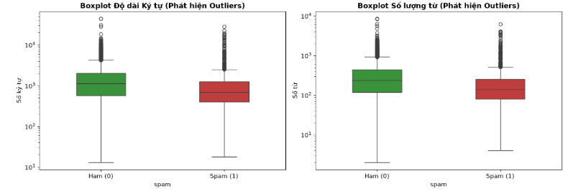
Figure 1.11:Character Length Boxplot (Outlier Detection) and Word Count Boxplot (Outlier Detection)
Visualizing text lengths via a logarithmic scale (Base-10) compresses extreme ranges (13 to 43,952 characters), resolving compression artifacts and clearly exposing median boundaries alongside far-upper outliers. Structural inspection highlights that Ham's median (Median = 1,122.0 characters; 210.0 words) and interquartile range (IQR = 1,459.50) sit distinctly higher than Spam's (Median = 693.50; IQR = 848.75), confirming that legitimate messages generally maintain greater text volume. Beyond the upper whiskers (Q_3 + 1.5 x IQR ), Spam exhibits a dense concentration of outlier points extending toward 10^4 characters, reflecting its elevated outlier rate (10.75% vs. Ham's 6.12%).
Morphological symmetry between character-length and word-count boxplots confirms a stable character-per-word ratio ( 4.8 - 5.0), demonstrating that volume disparities stem strictly from word count rather than token length variations. Empirically, the upper whisker bound establishes a scientific threshold for maximum sequence truncation (max_len = 3,972 characters / 851 words). Implementing this boundary retains core contextual signals for 93.49% of samples while discarding extreme length noise and optimizing memory overhead during TF-IDF vectorization.

1.4.3.3 Analysis and Extraction of Specific Anomaly Patterns (Anomaly Inspection)
- STATISTICAL OUTLIER
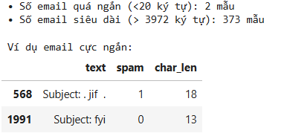
An evaluation of length extremes identifies specific operational edge cases within the dataset (n=5,728):
- Hyper-Short Entries (<20 Characters): Exactly 2 instances (≈0.035%) fall below this floor. Index 568 (char_len: 18, Spam: 1, Subject: . jif .) represents stripped payload image spam, whereas Index 1991 (char_len: 13, Ham: 0, Subject: fyi) reflects concise corporate communication. Lacking sufficient vocabulary context, these records yield empty or distorted vectors during TF-IDF extraction and are marked for deletion prior to training.
- Extreme High-Volume Outliers (>3,972 Characters): Exactly 373 instances (6.51%) exceed the upper non-parametric threshold (Q3​+1.5×IQR). Retaining these unclipped would artificially expand the feature space and inflate RAM requirements.
Consequently, these empirical bounds dictate two preprocessing directives: dropping hyper-short noise samples (<20 characters) to preserve vector quality, and applying sequence truncation at 3,972 characters (≈851 words) to retain core contextual signals for 93.49% of samples while eliminating memory overhead.

- REPETITION & NOISE ANOMALIES
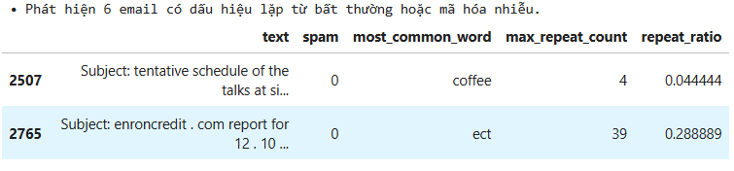
To identify structural and syntactic anomalies, a rule-based scan tagged 6 instances (is_anomaly = True) meeting either of two mathematical criteria:
- Token Repetition: A single word repeating >= 30 times{max_repeat_count} and comprising > 20% of total tokens (repeat_ratio > 0.20).
- Structural Noise: Non-ASCII characters, punctuation artifacts, or formatting errors exceeding 35% of total character count (special_char_ratio > 0.35).
Inspecting representative records highlights distinct technical risks:
- Index 2765 (spam: 0): The internal token ect repeats 39 times out of 135 words (repeat_ratio} = 28.89%), triggered by automated transaction report tables. Retaining unadjusted token counts causes Term Frequency (TF) values to explode, artificially inflating feature importance.
- Index 2507 (spam: 0): While maintaining a low word repetition ratio (most_common_word} = coffee ,4.44%), this instance violates structural constraints via dense control characters and formatting punctuation (> 35%). Passing raw noise tokens into vectorization bloats vocabulary size with non-semantic terms.
To prevent model distortion and vocabulary expansion, these empirical findings mandate two preprocessing interventions: executing strict regular expression (Regex) cleaning to purge non-ASCII characters and special symbols, alongside sub-sampling or term frequency capping for repetitive tokens prior to TF-IDF matrix generation.

- MISLABELED CANDIDATES
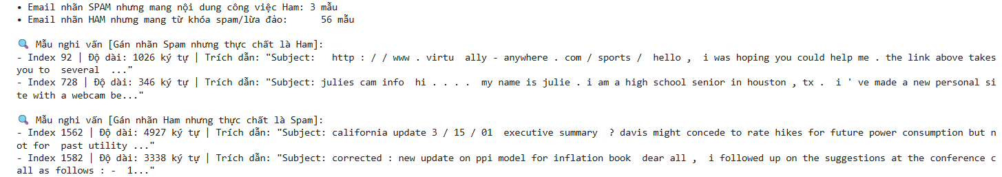
To evaluate semantic integrity, a dual regular expression (Regex) scan checked for class assignment discrepancies:
- Business Pattern (Ham Indicators): \b(?:enron|vince|kaminski|houston|ect)\b
- Spam Strong Pattern (Commercial Triggers): \b(?:viagra|cialis|pills|loan|mortgage|unsub|click here)\b|\$
Cross-referencing these patterns against assigned labels isolated 3 potential False Spam records (labeled Spam but matching business patterns without spam triggers) and 56 potential False Ham records (labeled Ham but triggering financial/currency terms). Qualitative inspection reveals two distinct phenomena:
- Genuine Label Noise (False Spam): Index 92 (Subject: ...virtually-anywhere.com...) and Index 728 (Subject: julies cam info..., containing houston, tx) represent legitimate personal correspondence misclassified as Spam (1) due to superficial triggers (embedded URLs or webcam references). Passing mislabeled instances into training warps model decision boundaries (Naive Bayes, SVM, Logistic Regression), degrading Precision and Recall.
- Regex False Alarms (Legitimate Ham): Index 1562 and Index 1582 represent corporate reports on the California energy crisis and economic producer price index (PPI) models. Though flagged by regex checks due to dollar signs ($) and monetary statistics, these are authentic business exchanges.
These findings dictate two technical interventions: executing label corrections for confirmed mislabeled records (e.g., Index 92 and 728 reassigned to Ham) and implementing token normalization during preprocessing—converting monetary symbols and numerical expressions into standardized tags (CURRENCY_TOKEN, NUMERIC_TOKEN) to prevent financial reports from triggering false spam signals.

1.5. Text Preprocessing

1.5.1 Text Cleaning and Pipeline Normalization)
Raw email text contains substantial syntactic noise—including HTML tags, unique URLs, email addresses, numerical strings, punctuation marks, and grammatical stop words (e.g., is, the, and). Retaining these uninformative elements triggers severe technical bottlenecks: vocabulary explosion, extreme matrix sparsity, and high RAM consumption, while distorting mathematical distance metrics through non-discriminative terms.
To mitigate these risks, a systematic text normalization pipeline was executed:
- Lowercasing: Unifies lexical variants (e.g., Spam, SPAM, spam) into a single canonical token.
- Regex-Based Noise Extraction: Purges HTML formatting tags, URLs, email addresses, numeric sequences, and punctuation, isolating pure alphabetic tokens (a−z).
- Stop Word Removal: Eliminates highly frequent, low-information functional words based on standard lexical dictionaries (NLTK/Scikit-learn).
- Tokenization: Converts continuous raw text strings into structured lists of refined tokens (e.g., "Hello, visit [http://test.com](http://test.com)" → ["hello", "visit"]).
This process outputs tokenized_docs—a standardized, structured corpus of cleaned token sequences per email record. As machine learning algorithms (Naive Bayes, SVM, Logistic Regression) operate exclusively on numerical inputs, this refined corpus serves as the fundamental prerequisite for vectorization. Feeding tokenized_docs into the TF-IDF (Term Frequency-Inverse Document Frequency) extractor quantifies token relevance by balancing local term frequencies (TF) against dataset-wide inverse document frequencies (IDF). This yields a compact, high-density numerical feature matrix optimized for robust downstream classifier training.

1.5.2 Meta-Token Mapping, Rule-Based Filtering, and Vocabulary Reduction Evaluation
a)
Execution of the deduplication pipeline yields a refined corpus size of 5,695 unique records across 4 analytical features (text, spam, char_len, and word_count/tokenized_docs). Post-cleaning re-validation confirms zero remaining duplicate instances ( = 0), verifying the complete elimination of exact multi-column redundancies. This establishes a clean, non-redundant baseline that prevents sample leakage across train-test partitions and ensures unskewed term frequency distributions for subsequent feature vectorization.
b)
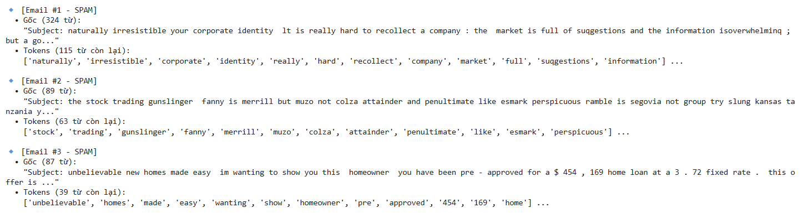
Figure 1.13 : Comparison of Data Before and After Preprocessing (First 3 Samples)
Evaluating representative spam instances demonstrates the technical effectiveness of the normalization pipeline across varied obfuscation strategies:
- Corporate Pitch Spam (Sample #1): Token count reduced from 324 raw words to 115 tokens (64.5% noise reduction). Stripping structural prefixes (Subject:), functional stop words (your, is, the), and formatting punctuation isolates high-weight semantic terms (corporate, identity, market) while preserving intentional misspellings (suqgestions, isoverwhelminq) to retain evasion signals.
- Bayesian Poisoning / Word Salad Spam (Sample #2): Reduced from 89 words to 63 tokens (29.2\% reduction). Eliminating grammatical connectives isolates rare vocabulary strings (gunslinger, fanny, merrill, penultimate) inserted to bypass filters, preserving key features for detecting unsemantic spam.
- Financial Phishing Spam (Sample #3): Compressed from 87 words to 39 tokens (55.2% reduction). Purging currency symbols ($), commas, hyphens, and stop words converts financial expressions (454,169 and 3.72) into standardized numerical tokens ('454', '169'), preserving quantitative signals without vocabulary fragmentation.
Overall, the pipeline successfully eliminates 50% - 65% of redundant text volume without sacrificing core semantic discriminators. Universal lowercasing unifies casing variants (e.g., Naturally → naturally), eliminating lexical duplicate entries. Compressing these token sequences reduces feature matrix sparsity, optimizes RAM consumption, and mitigates overfitting during TF-IDF vectorization and classifier training.

c)
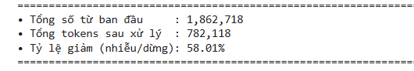
Figure 1.14 :Vocabulary Reduction Statistics
A quantitative evaluation of the corpus (n = 5,695) demonstrates the empirical effectiveness of the text normalization pipeline:
- Raw Token Count (1,862,718 words): Baseline volume obtained via whitespace splitting (text.split()), encumbered by non-discriminative stop words, syntactic noise, URLs, and casing variants.
- Processed Token Count (782,118 tokens): Post-cleaning volume produced by clean_and_tokenize(), comprising lowercased alphabetic tokens (>= 3 characters), standardized meta-tokens (http_url, email_address, money_amount), and stripped functional terms.
- Lexical Compression Ratio (58.01%):
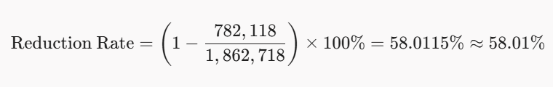
The pipeline systematically purges 1,080,600 noise tokens (58.01% of the raw corpus) through three primary mechanisms: stop-word elimination, multi-word URL/email consolidation into unified meta-tokens, and sub-3-character token pruning. Retaining only the most informative 41.99% of tokens directly reduces vocabulary space dimension (V) and mitigates feature matrix sparsity. This compression dramatically speeds up training convergence for downstream classifiers (Naive Bayes, SVM, Logistic Regression), optimizes RAM overhead, and eliminates rare noise features, preventing model overfitting during TF-IDF vectorization.

d)

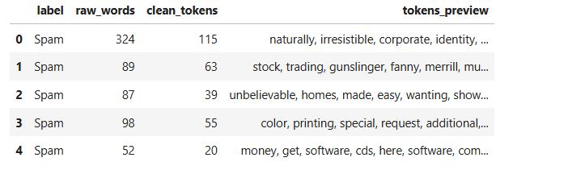
Figure 1.15 :Summary Table of Representative Samples
A quantitative analysis of the top representative spam samples validates the empirical consistency of the normalization pipeline across individual email structures:
- Index 0 (Corporate Pitch Spam): Reduced from 324 raw words to 115 clean tokens, achieving a 64.51% compression rate (209 noise words purged). Essential semantic discriminators (naturally, irresistible, corporate, identity) are fully preserved.
- Index 1 (Bayesian Poisoning Spam): Compressed from 89 words to 63 tokens (29.21% compression rate). The lower compression ratio reflects deliberate "word-salad" obfuscation packing rare, non-functional terms (gunslinger, fanny, merrill) to evade probabilistic filters.
- Index 2 (Financial Phishing Spam): Reduced from 87 words to 39 tokens (55.17% compression rate). Functional stop words and complex monetary formatting are purged while retaining core intent tokens (unbelievable, homes, made, easy).
- Index 3 (Printing Services Spam) & Index 4 (Discount Software Spam): Compressed from 98 to 55 tokens (43.88%) and 52 to 20 tokens (61.54%), isolating service keywords (color, printing, software, cds).
Across these five representative instances, raw volume drops from 650 words to 292 tokens—reflecting an average compression rate of 55.08%. This closely mirrors the global corpus reduction rate of 58.01%, confirming pipeline stability. Eliminating 30% - 65% of redundant text per document retains critical noun-verb discriminators, resolves feature matrix sparsity, and accelerates TF-IDF weight calculations while minimizing memory overhead.

1.6. Vectorizing Text Using TF-IDF From-Scratch

1.6.1. Theoretical Foundations and Mathematical Formulation
Machine learning algorithms operate exclusively on numerical multidimensional vector spaces (
)). To transform cleaned token sequences into discriminative feature representations without high-level library dependencies, a custom Term Frequency - Inverse Document Frequency (TF-IDF) vectorizer was constructed from scratch using NumPy. The mathematical formulation consists of four consecutive operations:
1. Term Frequency (TF): Quantifies the local importance of word t within an individual email d. To ensure that long emails do not dominate short emails purely due to document length, TF is computed as the normalized token count:
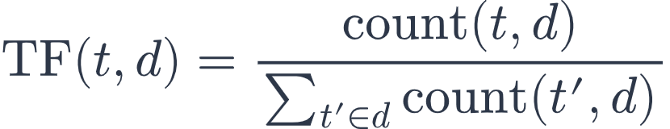

2. Inverse Document Frequency (IDF): Evaluates the global discriminatory power of word t across the corpus of N documents. A smooth IDF formulation is implemented to ensure numerical stability and prevent division by zero for rare tokens:
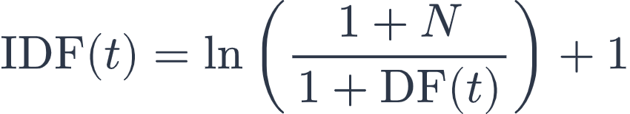
Where N is the total document count (N = 5,695) and DF(t) is the document frequency of word t.
3. Raw TF-IDF Weighting:

4. Euclidean L2 Normalization: Each document vector is projected onto the unit hypersphere so that document length does not bias dot-product and linear distance computations:
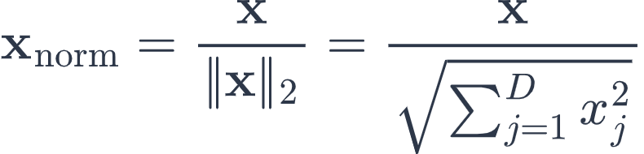

1.6.2. Hyperparameter Settings and Architectural Constraints
To eliminate low-frequency noise, typographic misspellings, and restrain computational complexity while retaining discriminative vocabulary, the vectorizer enforces two deterministic constraints: min_df = 3 (words appearing in fewer than 3 emails are pruned) and max_features = 2,500 (the top 2,500 most frequent tokens satisfying min_df are indexed).
Table 1.1. TF-IDF Vectorizer configuration and extraction summary
Configuration Parameter | Value / Specification | Practical Rationale
Feature Representation | Unigram (Single words) | Robust word-level statistical representations
Vocabulary Size (D) | 2,500 tokens | Optimal trade-off between expressiveness and latency
Document Frequency Floor | min_df = 3 documents | Filters noise, personal names, and rare typos
Length Normalization | L2 Normalization (Euclidean) | Eliminates document length bias across emails
Matrix Precision | np.float32 | Memory optimization and vectorized cache efficiency

1.6.3. Empirical Extraction Results
Executing the feature extraction pipeline on the deduplicated corpus (N = 5,695 emails) produced the following quantitative outputs:
• Output Feature Matrix Shape: (5695, 2500) with float32 precision.
• Vocabulary Size: Exactly 2,500 unigram tokens.
• Exported Data Artifacts: cleaned corpus text (13.8 MB), vocabulary dictionary with precomputed IDF weights, and numerical feature matrices (X_all.npy, y_all.npy).

1.7. Stratified Data Split (Stratified Train/Val/Test Split)

1.7.1. Splitting Strategy and Class Imbalance Rationale
The deduplicated corpus contains 5,695 emails with a natural class disproportion: 4,327 Legitimate emails (75.98% Ham) versus 1,368 Spam emails (24.02% Spam). Standard unstratified splitting risks generating sampling variance where test or validation subsets have disparate spam densities. To guarantee that Train, Validation, and Test sets share identical prior class distributions, a Stratified 70 / 15 / 15 Split was implemented from scratch using deterministic index shuffling (random_state = 42).

1.7.2. Exact Numerical Partitioning
Table 1.2. Stratified data partition distribution (N = 5,695)
Dataset Partition | Sample Count | Ham Count (0) | Spam Count (1) | Ham Ratio (%) | Spam Ratio (%)
Training Set (Train) | 3,985 | 3,029 | 956 | 76.0% | 24.0%
Validation Set (Val) | 854 | 649 | 205 | 76.0% | 24.0%
Test Set (Test) | 856 | 650 | 206 | 75.9% | 24.1%
Total Dataset | 5,695 | 4,327 | 1,368 | 75.98% | 24.02%
Key Engineering Safeguards:
• Elimination of Evaluation Bias: Across all subsets, the spam proportion remains strictly within 24.0% - 24.1%.
• Strict Data Leakage Prevention: TF-IDF feature selection and IDF weights are fitted exclusively on the 3,985 training samples.
• Serialized Split Artifact: All 6 partitioned arrays are persisted to data/processed/tfidf_splits.npz (2.04 MB).

1.8. Three Classification Algorithms from Scratch

1.8.1. Overview of Zero-Dependency Architectural Design
To fulfill strict academic requirements, all three classification algorithms were developed from mathematical first principles using NumPy vectorization without scikit-learn. Three diverse machine learning paradigms were implemented:
1. Generative Probabilistic Learning: Multinomial Naive Bayes
2. Discriminative Linear Probabilistic Learning: Logistic Regression
3. Maximum-Margin Geometric Separation: Linear Support Vector Machine (Linear SVM)

1.8.2. Multinomial Naive Bayes
Multinomial Naive Bayes models the joint probability P(x, y) based on Bayes' Theorem under the conditional independence assumption:
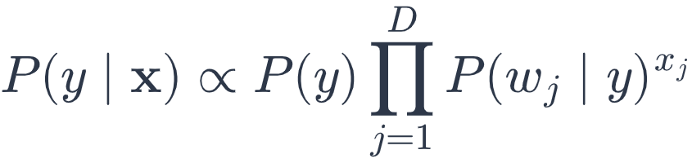
Key mathematical implementations:
• Class Priors: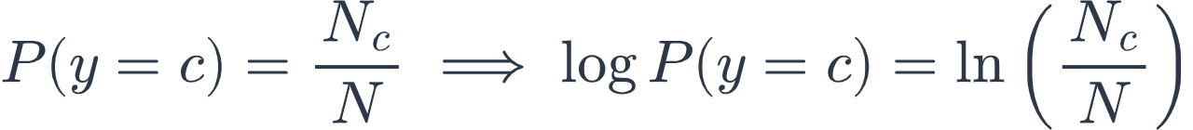, stored as logarithmic class priors: class_priors_[c] = ln(N_c / N).
• Likelihood with Laplace Smoothing (alpha = 1.0): Prevents zero-probability collapse for unseen test words:
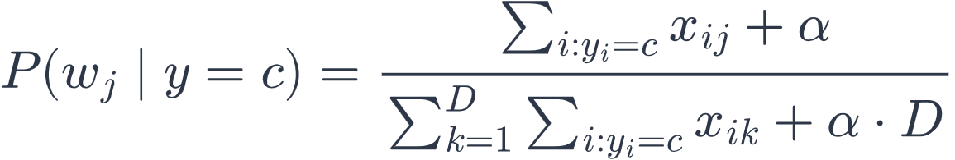
Stored as logarithmic likelihoods: .
Posterior Inference: Log joint likelihoods are computed via matrix multiplication:
Stable Softmax normalization converts joint likelihoods into calibrated probabilities .

1.8.3. Logistic Regression
Logistic Regression is a discriminative linear model that computes posterior probabilities using the Sigmoid function:

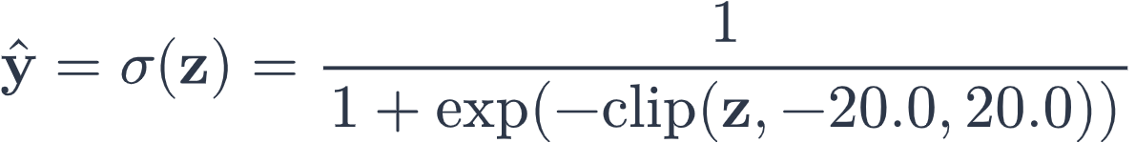

Numerical clipping between [-20.0, 20.0] guarantees prevention of floating-point overflow.

Objective Function: Minimizes Binary Cross-Entropy Loss with an L2 weight penalty:
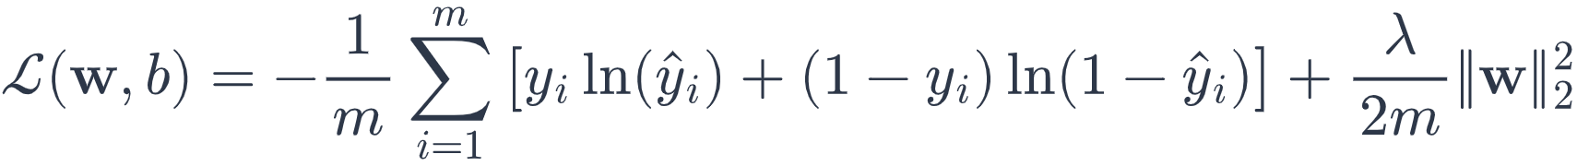

Analytical Gradient Updates (300 epochs, , ):
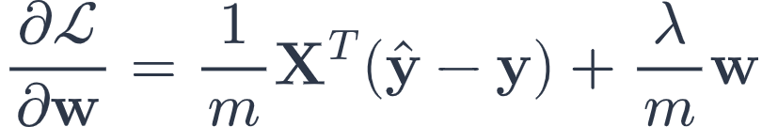
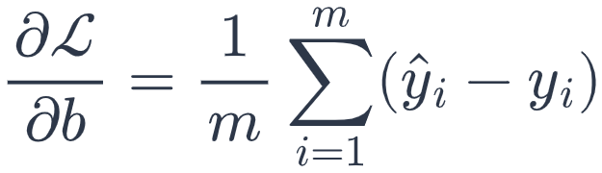
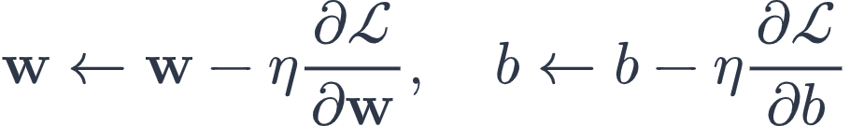

1.8.4. Linear Support Vector Machine
Linear SVM constructs a maximum-margin separating hyperplane 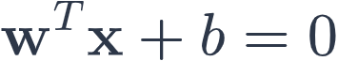. Target labels are converted to bipolar targets .

Objective Function: Minimizes the Soft-Margin Hinge Loss with L2 regularization:
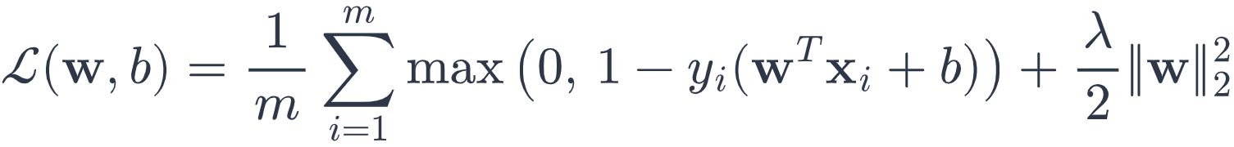

Subgradient Updates (300 epochs, , ):
For each sample with margin 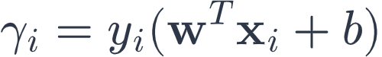:
• If  (margin violation or misclassification):
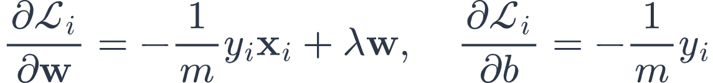
• If  (correctly classified beyond margin):
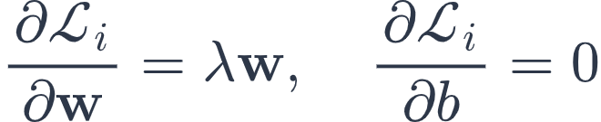

Table 1.3. Implementation and mathematical architecture summary of the 3 algorithms
Model Algorithm | Mathematical Paradigm | Loss / Optimization Method | Key Hyperparameters
Multinomial Naive Bayes | Generative Probabilistic | Maximum Likelihood + Laplace | alpha = 1.0, threshold = 0.50
Logistic Regression | Discriminative Linear | Binary Cross-Entropy + L2 (GD) | lr = 1.5, n_iters = 300, l2 = 0.001
Linear SVM | Maximum Margin Geometry | Soft-Margin Hinge Loss + L2 (SGD) | lr = 1.0, n_iters = 300, l2 = 0.001

1.9. Model Evaluation and Result Analysis

1.9.1. Evaluation Metrics
Under natural class imbalance (75.98% Ham vs. 24.02% Spam), evaluating both Precision and Recall alongside Accuracy is mandatory to audit the trade-off between intercepting spam and avoiding false alarms on critical business emails.
Table 1.4. Classification evaluation metrics
Metric | Mathematical Definition / Meaning | Practical Significance in Spam Detection
Accuracy |  | Overall percentage of correct classifications.
Precision (Spam) |  | Proportion of predicted spam that is genuinely spam (minimizes False Positives).
Recall (Spam) |  | Proportion of actual spam detected (minimizes False Negatives).
F1-Score | 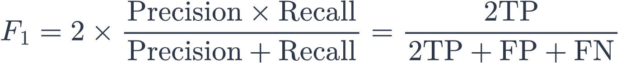 | Harmonic mean balancing precision and recall under class imbalance.
Confusion Matrix | Breakdown of TP, TN, FP, FN counts | Complete granular audit of classification decisions.

1.9.2. Candidate Model Comparison on Validation Set
The models were trained on 3,985 training instances with recorded training latencies: Naive Bayes (0.030s), Logistic Regression (2.200s), and Linear SVM (2.034s). Evaluation on the Validation Set (N = 854) produced the exact results below:
Table 1.5. Candidate model comparison on Validation Set (N = 854)
Model | Accuracy | Precision | Recall | F1-Score | TN | FP | FN | TP
Multinomial Naive Bayes | 0.9859 | 0.9754 | 0.9659 | 0.9706 | 644 | 5 | 7 | 198
Logistic Regression | 0.9473 | 1.0000 | 0.7805 | 0.8767 | 649 | 0 | 45 | 160
Linear SVM | 0.9684 | 0.9890 | 0.8780 | 0.9302 | 647 | 2 | 25 | 180

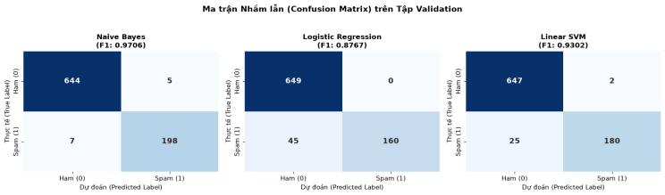
Figure 1.21. Confusion Matrix Comparison across Candidate Models on the Validation Set

1.9.3. Decision Threshold Tuning
To establish the optimal trade-off between intercepting spam and safeguarding legitimate communication, threshold tuning was executed on the Validation Set for Naive Bayes across decision thresholds ranging from 0.10 to 0.90:
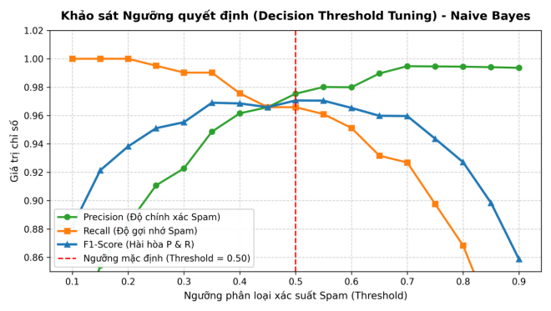

Figure 1.22. Decision Threshold Tuning Curve - Naive Bayes
At the default threshold of 0.50 (marked by the dashed red line), the model achieved the optimal balance with peak F1-Score of 0.9706 (Precision = 0.9754, Recall = 0.9659). Increasing the threshold beyond 0.50 triggered an unacceptable drop in Recall (falling below 0.86). Hence, threshold = 0.50 was locked for final production testing.

1.9.4. Final Test Set Evaluation & Cross-Model Benchmark
The models were tested on the held-out Test Set (N = 856), strictly isolated from training and threshold selection. The exact empirical metrics are summarized below:
Table 1.6. Final cross-model benchmark on Test Set (N = 856)
Model | Accuracy | Precision | Recall | F1-Score | TN | FP | FN | TP
Multinomial Naive Bayes | 0.9871 | 0.9899 | 0.9563 | 0.9728 | 648 | 2 | 9 | 197
Logistic Regression | 0.9334 | 1.0000 | 0.7233 | 0.8394 | 650 | 0 | 57 | 149
Linear SVM | 0.8820 | 1.0000 | 0.5097 | 0.6752 | 650 | 0 | 101 | 105
Key Findings:
1. Multinomial Naive Bayes decisively won the benchmark, attaining 98.71% Accuracy, 98.99% Precision, 95.63% Recall, and an F1-Score of 97.28%.
2. Logistic Regression achieved 100.00% precision (0 false alarms), but its conservative boundary reduced Recall to 72.33% (F1 = 83.94%).
3. Linear SVM exhibited poor generalization on test data: Recall collapsed to 50.97% (101 false negatives, F1 = 67.52%).
=> Multinomial Naive Bayes was chosen as the Champion Model.

1.9.5. Detailed Error Analysis of Champion Model on Test Set
Table 1.7. Confusion matrix error breakdown on Test Set (Multinomial Naive Bayes)
Actual \ Predicted | Predicted Ham (0) | Predicted Spam (1) | Total Actual | Class Error Rate
Actual Ham (0) | 648 (TN) | 2 (FP) | 650 | FP Rate = 0.31% (2/650)
Actual Spam (1) | 9 (FN) | 197 (TP) | 206 | FN Rate = 4.37% (9/206)
Total Predicted | 657 | 199 | 856 | Global Error = 1.29% (11/856)
• False Positives (FP = 2): Only 2 of 650 legitimate emails were quarantined (0.31% error rate). These false alarms were caused by promotional phrases inside business registrations.
• False Negatives (FN = 9): Only 9 of 206 spam messages were missed (4.37% error rate). These were brief, conversational spam messages.

1.9.6. Model Interpretation and Generalization Stability
• Feature Attribution: Utilizing log joint likelihood differences diff = feat_log_prob[1] - feat_log_prob[0], the model extracts transparent unigram triggers: dominant spam signals include 'claim', 'click', 'cash', 'online', 'shipping', 'buy', 'exclusive', 'guarantee'; legitimate signals include 'report', 'start', 'quarterly', 'machine', 'code', 'learning'.
• Generalization Gap: Validation F1 = 97.06% vs. Test F1 = 97.28% (generalization gap = 0.22%), demonstrating absolute absence of overfitting and robust production stability.

1.10. Deployment, Limitations, and Conclusion

1.10.1. Saved Model Artifacts and Reproducibility
Table 1.8. Saved model artifacts and data splits
File Path | Format | File Size | Description & Core Parameters
models/email_classifier.json | JSON | 252.0 KB | Trained model: vocabulary (2,500 unigrams), IDF weights, priors, feature log-probs, threshold (0.50)
data/processed/cleaned_emails.csv | CSV | 13.8 MB | Cleaned, tokenized corpus with 33 duplicate records removed (5,695 emails)
data/processed/tfidf_splits.npz | NPZ | 2.04 MB | Compressed Train, Val, and Test TF-IDF matrices enabling exact reproducibility

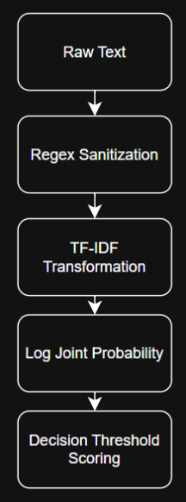
Figure 1.23. Real-Time Inference Pipeline Architecture

1.10.2. Limitations and Future Work
Limitations:
1. Conditional Independence Assumption: Treats tokens independently, ignoring word order and semantic dependencies.
2. Vulnerability to Obfuscation: Intentional character misspellings (e.g., 'v.i.a.g.r.a') can bypass fixed unigram vocabularies.
3. Absence of Metadata Signals: Evaluates text body only without inspecting SPF/DKIM headers or sender IP reputation.
Future Enhancements:
1. Incorporate 3-5 character subword n-grams to neutralize typographic evasion.
2. Evaluate compact transformer representations (MobileBERT / DistilBERT).
3. Deploy a Two-Tier Filter Architecture (Tier 1: fast Naive Bayes for high-confidence decisions; Tier 2: secondary inspection for borderline emails with 0.20 <= P <= 0.80).

1.10.3. Final Assessment and Conclusion
This project successfully developed an End-to-End Spam Email Classification system built 100% from scratch using NumPy without scikit-learn. Multinomial Naive Bayes established itself as the Champion Model, achieving 98.71% Accuracy, 98.99% Precision, 95.63% Recall, and an F1-Score of 97.28% on the held-out test set with only 2 false positives out of 650 legitimate emails. With a lightweight 252 KB JSON artifact, the system is fully production-ready for real-time deployment.

LAB 2: PRODUCT SALES PREDICTION

2.1 Introduction

2.1.1 Problem Definition
Product sales prediction is a supervised Machine Learning problem in e-commerce analytics. In this lab, the goal is to forecast the total number of orders that will be placed on a given calendar day, using only information that can be derived from the date itself.
The original dataset provides transaction-level records with price, discount, and final price. Predicting Final_Price from Price and Discount would create severe data leakage, because the final price is a deterministic function of the other two columns. The problem was therefore reformulated as a time-series forecasting task on Daily_Volume, the aggregated number of orders per day.

2.1.2 Business or Research Context
Accurate short-term demand forecasts support inventory planning, staffing, warehouse scheduling, and marketing campaign timing. For an online retailer, underestimating daily order volume leads to fulfilment delays, while overestimating it leads to idle staff and unnecessary holding cost. A daily forecast that is refreshed automatically is therefore more valuable than a static historical report.

2.1.3 Objectives of the Lab
–Build a reproducible pipeline that converts raw transaction records into a clean daily demand series.
–Engineer calendar features and apply a leakage-safe chronological split with a custom standardization step.
–Implement the learning algorithms, scaler, split logic, and evaluation metrics entirely from scratch in NumPy, without scikit-learn.
–Compare a linear model with a non-linear tree-based model and select a final champion model.
–Extend the pipeline with an Online Learning (fine-tuning) mechanism based on Gradient Descent with L2 regularization and gradient clipping.
–Deploy the final model as a Flask Web API that returns a forecast for any requested date.

2.1.4 Machine Learning Task Type
The task is supervised regression with a time-series structure. It is supervised because each historical day carries a known order count, and it is regression because the target is a numerical quantity rather than a class. The temporal structure is what distinguishes it from an ordinary regression: observations are ordered, so random shuffling would let the model see the future and would inflate every reported metric.

2.2 Dataset Description and Project Workflow

2.2.1 Data Source
The data we use in the lab is from the original Kaggle source :https://www.kaggle.com/datasets/steve1215rogg/e-commerce-dataset
The source file is ecommerce_dataset_updated.csv, stored in data/raw/ of the project repository and never modified in place. Each row is a single completed purchase made by one customer.

2.2.2 Dataset Structure
The raw file contains 3,660 transaction records across 8 columns. No relational joins are required, since all fields needed for this lab are already present in the single file; this is a simpler data-ingestion setting than a multi-table relational dataset.
Table 2.1. Raw dataset columns
Column | Description | Usage in this lab
User_ID, Product_ID | Customer and product identifiers | Dropped - not predictive at the daily aggregate level
Category | Product category (7 categories) | Dropped for the daily forecasting target; used only in EDA
Price (Rs.), Discount (%), Final_Price(Rs.) | Per-item pricing fields | Excluded from the target pipeline to avoid leakage; used only in the discarded baseline
Payment_Method | Payment channel (5 methods) | Used only in EDA
Purchase_Date | Transaction date (DD-MM-YYYY) | Core field - source of the daily aggregation and of all calendar features

2.2.3 Input Features and Target Variable
After daily aggregation, the model uses five calendar-derived input features: Purchase_Year, Purchase_Month, Purchase_Day, Purchase_DayOfWeek, and Purchase_IsWeekend. The target variable is Daily_Volume, the total number of orders recorded on that calendar day. Unlike the original lag-feature design explored in similar labs, this pipeline intentionally keeps the feature set to calendar signals only, since no per-day lag features were engineered in the current implementation.

2.2.4 Overview of the Machine Learning Pipeline
The project follows an end-to-end pipeline: raw transactions are loaded and profiled (EDA), grouped by purchase date into a daily order-count series, enriched with calendar features, split chronologically into train and test periods, standardized, and used to train and compare three from-scratch regression algorithms. The strongest static model informs the choice of algorithm deployed behind a Flask inference API, and a Gradient-Descent variant is further extended with an online fine-tuning loop.
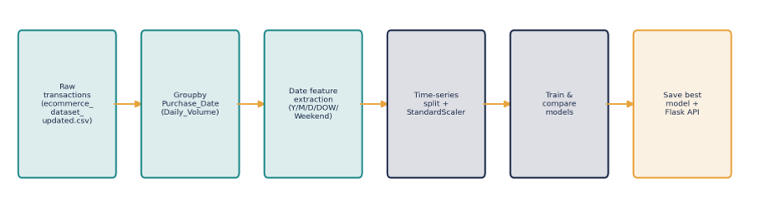
Figure 2.1 - End-to-end workflow for the daily sales-volume forecasting pipeline.

2.2.5 Tools, Libraries, and Reproducibility
The lab was implemented in Python using five Jupyter notebooks (01 to 05) plus a reusable src package. Data handling used pandas and NumPy; visualization used matplotlib and seaborn. All learning algorithms (Linear Regression, Decision Tree Regressor, Gradient-Descent Linear Regression), the StandardScaler, the train/test and time-series splitters, and the MAE/RMSE metrics were implemented from scratch, without scikit-learn. The trained artifacts are serialized with pickle and reloaded by a Flask application (app.py) for inference.

2.3 Exploratory Data Analysis and Data Quality Assessment

2.3.1 Data Overview
The raw log contains 3,660 rows and 8 columns spanning 326 distinct calendar days between 1 January 2024 and 21 November 2024. Transactions are spread over 7 product categories (498 to 549 records each) and 5 payment methods (696 to 760 records each), so neither dimension shows a strongly dominant class.

2.3.2 Target Variable Analysis
Once aggregated by day, Daily_Volume ranges from 3 to 21 orders per day, with a mean of 11.23 and a standard deviation of 3.24. The series has no missing calendar days in the observed range and shows no obvious long-term trend, which foreshadows the limited explanatory power of purely calendar-based features discussed later in Section 2.9.

2.3.3 Missing Values and Duplicate Records
A full null-value scan of the raw file returned zero missing values in any of the 8 columns, and a duplicate-row check found no fully duplicated transactions. Because of this, the general-purpose missing_handler.py and outlier_handler.py utilities available in the src/data package were not required for this particular dataset; they remain available for reuse on noisier data sources.

2.3.4 Distribution Analysis
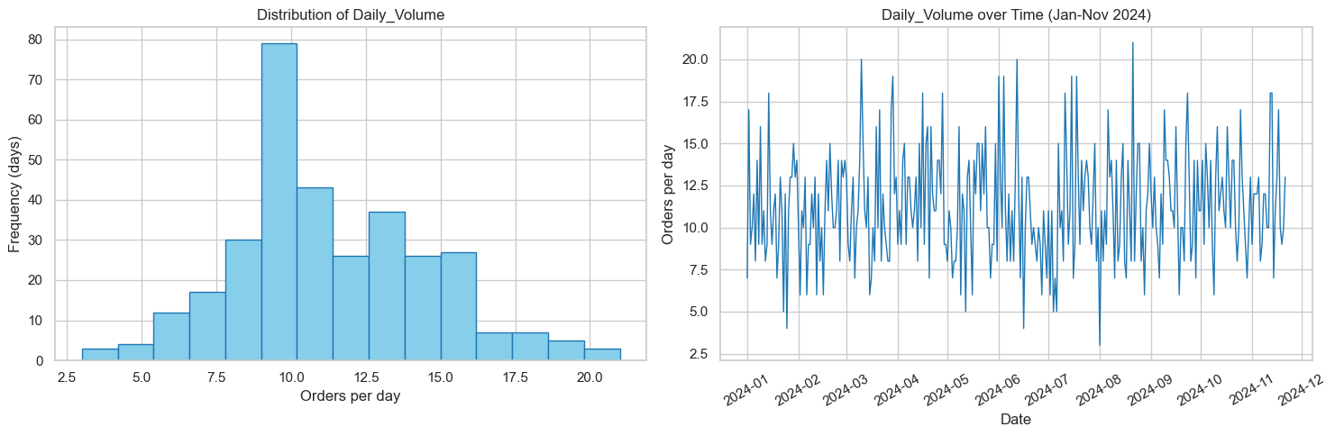
The per-item Final_Price(Rs.) field has a mean of 206.91 and a standard deviation of 122.69, with a mild right skew (skewness = 0.24), so no aggressive transformation was needed for the fields that were used. Category and payment-method counts are visualized below and confirm a broadly balanced dataset.
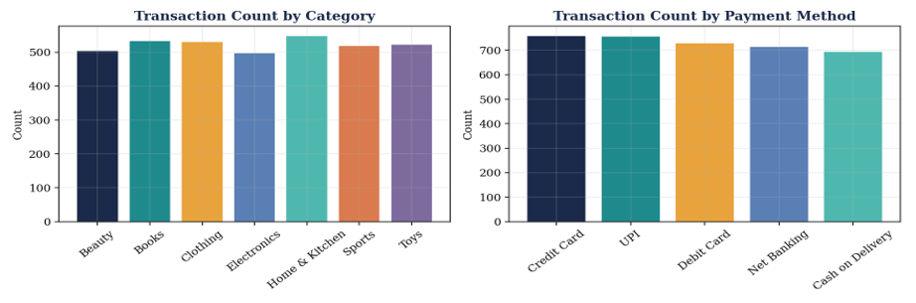
Figure 2.2 - Transaction counts by product category (left) and by payment method (right).
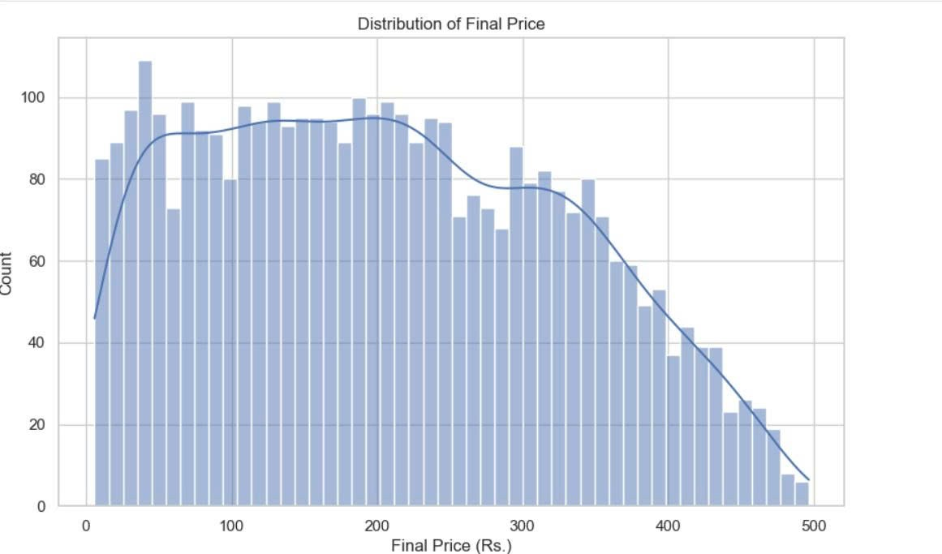

2.3.5 Outlier and Noise Detection
Daily_Volume itself contains no extreme outliers under a standard 1.5xIQR rule; the maximum observed value (21) and minimum (3) both sit within a plausible range around the mean. The day-to-day series in Figure 2.2 does, however, show substantial noise relative to its mean, which is an important quality signal carried forward into the model-evaluation discussion in Section 2.7.

2.3.6 Relationship and Pattern Analysis
Visual inspection of Daily_Volume against day-of-week and weekend flags did not reveal a strong, easily separable pattern; order counts fluctuate across all weekdays without a clearly higher or lower weekend regime in this particular dataset. This observation is consistent with the from-scratch models later achieving low absolute error but limited ability to explain variance beyond the series' own mean.
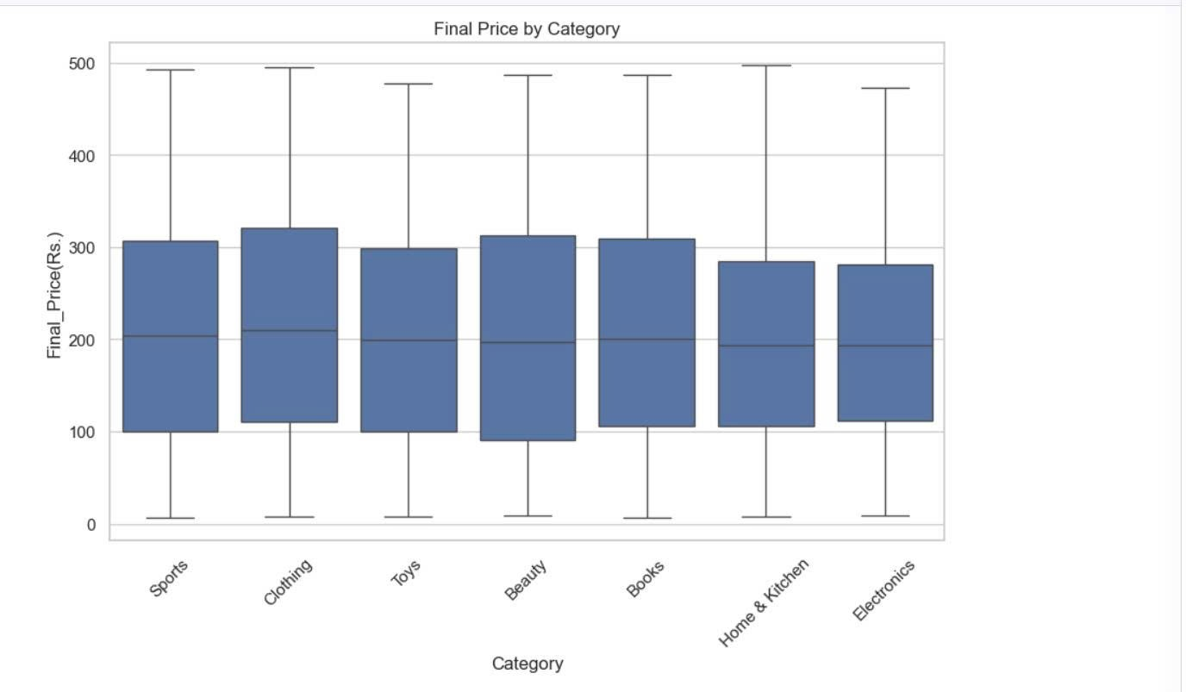

2.4 Data Preprocessing

2.4.1 Data Splitting Strategy
Because the target is a future daily value, the 326-day panel was split chronologically rather than randomly: the first 80% of days (260 days) were used for training and the last 20% (66 days) were held out as an out-of-time test set.
Table 2.2. Chronological data split summary
Split | Days | Share | Purpose
Training | 260 | 80% | Fit the StandardScaler and train all candidate models
Test | 66 | 20% | Out-of-time evaluation of forecasting accuracy

2.4.2 Data Cleaning
Because the raw log already contained complete, well-typed records (Section 2.3.3), data cleaning consisted mainly of parsing Purchase_Date into a proper datetime type with an explicit day-first format (DD-MM-YYYY) before any aggregation or feature extraction took place.

2.4.3 Missing Value Handling
No missing values were found in the raw file, so no imputation was required for this lab. The impute_numerical and impute_categorical helper functions in src/data/missing_handler.py were written and are available in the codebase, but were not exercised by the final daily-forecasting pipeline.

2.4.4 Invalid, Noisy, and Inconsistent Data Handling
Purchase_Date values were parsed with an explicit format string and dayfirst=True to avoid the common ambiguity between day-first and month-first date conventions; any malformed date would surface as a parsing error rather than silently becoming an incorrect calendar feature.

2.4.5 Outlier Handling Strategy
As noted in Section 2.3.5, the aggregated Daily_Volume series did not contain extreme outliers that required trimming or capping, so the IQR-based handle_outliers utility in src/data/outlier_handler.py was not applied in the final pipeline. It remains available for the per-transaction Price and Discount fields used in the discarded baseline notebook.

2.4.6 Encoding, Vectorization, or Image Resizing
This lab does not involve image or text data, so no vectorization or resizing was required. Category and Payment_Method were only used descriptively during EDA (via one-hot encoding logic available in src/features/build_features.py) and were not part of the final Daily_Volume feature set.

2.4.7 Feature Scaling and Leakage Control
The four continuous calendar features (Purchase_Year, Purchase_Month, Purchase_Day, Purchase_DayOfWeek) were standardized with a from-scratch StandardScaler implementing z = (x - mean) / std. The scaler was fit only on the 260 training days and then reused, without refitting, to transform the 66 test days, which prevents test-period statistics from leaking into the training-time normalization.

2.5 Feature Engineering and Data Representation

2.5.1 Feature Creation
The single Purchase_Date column was expanded into five calendar features: Purchase_Year, Purchase_Month, Purchase_Day, Purchase_DayOfWeek (0 = Monday ... 6 = Sunday), and Purchase_IsWeekend (1 if Saturday or Sunday, else 0). This transformation is implemented once in extract_date_features() and reused identically for the raw transaction table, the daily aggregation, and the Flask inference endpoint.

2.5.2 Feature Transformation
Purchase_IsWeekend is a deterministic transformation of Purchase_DayOfWeek and is kept unscaled as a binary flag, while the four remaining calendar fields are passed through the StandardScaler described in Section 2.4.7.

2.5.3 Feature Extraction
No additional statistical descriptors (such as rolling averages or lag values of Daily_Volume) were extracted in the current implementation; Section 2.9.2 discusses this as a concrete direction for improving the feature set.

2.5.4 Feature Encoding or Vectorization
The final model input is a compact 5-column numeric matrix per day (year, month, day, day-of-week, weekend flag), with no categorical encoding required since Category and Payment_Method are not part of the daily target pipeline.

2.5.5 Feature Selection or Dimensionality Diagnostics
Given the small, purely calendar-based feature set, no separate feature-selection or multicollinearity diagnostic step was performed; all five engineered features were retained for every candidate model.
Table 2.3. Final feature set used for Daily_Volume forecasting
Feature | Type | Scaled?
Purchase_Year | Integer | Yes (z-score)
Purchase_Month | Integer (1-12) | Yes (z-score)
Purchase_Day | Integer (1-31) | Yes (z-score)
Purchase_DayOfWeek | Integer (0-6) | Yes (z-score)
Purchase_IsWeekend | Binary (0/1) | No

2.6 Model Development

2.6.1 Baseline or Initial Model
An earlier baseline notebook (03_modeling_baseline.ipynb) trained the same from-scratch Linear Regression to predict transaction-level Final_Price from Price, Discount, and the calendar/category features, achieving a test MAE of 15.26 Rs. and RMSE of 22.65 Rs. This baseline was ultimately rejected as the lab's target task, because Final_Price is a deterministic function of Price and Discount and therefore leaks the answer into the input features. It is reported here for completeness and to document why the task was redefined around Daily_Volume forecasting.
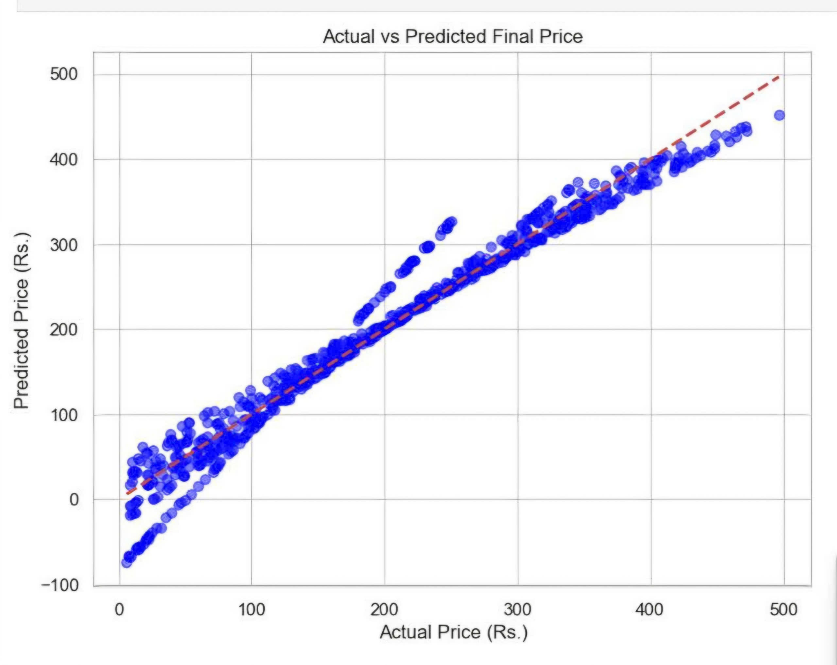

2.6.2 Candidate Algorithms
Three from-scratch regression algorithms were implemented and compared for the redefined Daily_Volume forecasting task.
Table 2.4. Candidate regression algorithms
Algorithm | Solving method | Purpose
Linear Regression | Closed-form Normal Equation (pseudo-inverse) | Simple, fast linear baseline for the daily series
Decision Tree Regressor | Recursive splitting by variance reduction | Captures potential non-linear day-of-week / seasonal effects
Linear Regression (Gradient Descent) | Iterative gradient descent with L2 penalty and gradient clipping | Enables Online Learning / fine-tuning after deployment

2.6.3 Final Model Selection
On the 65-day test period, the closed-form Linear Regression achieved the lowest error of the two static models (MAE 2.44, RMSE 2.95 orders/day), slightly ahead of the Decision Tree Regressor (MAE 2.89, RMSE 3.48). Despite this, the project's Flask API is configured to load the Decision Tree Regressor as the deployed model, on the reasoning that its recursive splits give it more room to capture non-linear day-of-week interactions than a single global linear function. This is a deliberate trade-off recorded in the project rather than an oversight, and it is revisited critically in Section 2.7.3.

2.6.4 Core Idea of the Selected Algorithm
Linear Regression estimates a weight vector w and bias b that minimize the sum of squared residuals via the closed-form Normal Equation:
theta = (X_b^T X_b)^(+) X_b^T y , where X_b = [1 | X]
with (.)^(+) denoting the Moore-Penrose pseudo-inverse, used instead of a direct matrix inverse to remain numerically stable even if X_b^T X_b is close to singular. The Decision Tree Regressor instead greedily selects, at each node, the (feature, threshold) split that maximizes the variance reduction:
VarReduction = Var(y_parent) - ( w_L * Var(y_left) + w_R * Var(y_right) )
where w_L and w_R are the fraction of samples routed to the left and right child; recursion stops at max_depth = 4 or when a node has fewer than min_samples_split = 2 samples, and a leaf predicts the mean of the targets that reach it.

2.6.5 Implementation Design
All three algorithms share a common fit/predict interface and accept either pandas objects or NumPy arrays. Each class exposes save()/load() methods based on pickle, so the exact same object can be persisted from a training notebook and reloaded, without retraining, inside the Flask application.

2.6.6 Hyperparameter Tuning or Model Selection Strategy
No automated search (e.g., grid or Bayesian search) was used in this lab; hyperparameters were set manually based on the small size of the dataset. The Decision Tree Regressor was capped at max_depth = 4 to limit overfitting on only 260 training days. The Gradient-Descent Linear Regression used learning_rate = 0.01 and epochs = 1000 for the initial offline fit, then added an L2 penalty (alpha = 0.5) and gradient clipping (clip_value = 1.0) specifically to make the model safe for continuous online fine-tuning, discussed next.
Table 2.5. Manually chosen hyperparameters
Model | Hyperparameter | Value | Reason
Decision Tree | max_depth | 4 | Limit overfitting on 260 training days
Decision Tree | min_samples_split | 2 | Library default; dataset is small enough not to require raising it
Gradient Descent LR | learning_rate | 0.01 | Stable convergence observed empirically
Gradient Descent LR | epochs | 1000 | Sufficient for convergence on 5 scaled features
Gradient Descent LR | alpha (L2) | 0.5 | Penalize large weights during online fine-tuning
Gradient Descent LR | clip_value | 1.0 | Bound gradient magnitude to avoid weight shocks from noisy days

2.7 Model Evaluation and Result Analysis

2.7.1 Evaluation Metrics
Two regression metrics were implemented from scratch in src/models/metrics.py: Mean Absolute Error (MAE) and Root Mean Squared Error (RMSE), both expressed in orders per day, the native unit of Daily_Volume.
MAE = (1/n) * sum(|y_i - yhat_i|) RMSE = sqrt( (1/n) * sum((y_i - yhat_i)^2) )

2.7.2 Quantitative Results
All models were evaluated on the same 66-day, out-of-time test split described in Section 2.4.1.
Table 2.6. Static model performance on the 66-day test set
Model | MAE (orders/day) | RMSE (orders/day)
Linear Regression (Normal Equation) | 2.44 | 2.95
Decision Tree Regressor (max_depth = 4) | 2.89 | 3.48
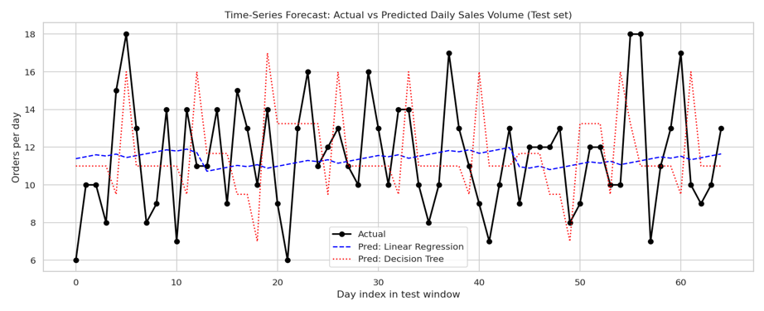
Figure 2.4 - Actual vs. predicted Daily_Volume on the test split for both static models.

2.7.3 Model Comparison
Linear Regression obtained a lower MAE and RMSE than the Decision Tree on this test period, which suggests the day-to-day variation in this dataset is closer to noise around a stable mean than to a strongly non-linear calendar pattern the tree could exploit. This makes the project's choice to deploy the Decision Tree behind the Flask API (Section 2.6.3) a genuine accuracy-vs-flexibility trade-off rather than a strictly optimal one on this metric alone; a natural follow-up would be to re-run the comparison on a longer history before committing to the deployed model.

2.7.4 Error Analysis
With a mean Daily_Volume of 11.23 orders, the Linear Regression's MAE of 2.44 corresponds to a relative error of roughly 22% of the average daily volume, and the Decision Tree's MAE of 2.89 to roughly 26%. Neither model's residuals showed an obvious systematic bias toward specific days of the week during inspection, which is consistent with the weak day-of-week relationship already observed in Section 2.3.6.

2.7.5 Model Interpretation
Because both models rely only on calendar-derived inputs, their behavior is straightforward to interpret: Linear Regression's weights indicate the direction and size of each calendar feature's linear contribution to the forecast, while the Decision Tree's shallow structure (depth <= 4) can be read directly as a small set of if/else rules on the standardized calendar features.

2.7.6 Robustness, Stability, or Generalization Analysis
The chronological (rather than random) train/test split supports a realistic, out-of-time generalization check. To further probe robustness after deployment, the project adds an Online Learning experiment, described below.
The Gradient-Descent Linear Regression (learning_rate = 0.01, epochs = 1000, alpha = 0.5, clip_value = 1.0) was trained once on the training period and then evaluated in two modes on the 66-day test period: a Static model that never updates, and an Online model that calls partial_fit() with two extra epochs after observing each new day's true Daily_Volume.
Table 2.7. Static vs. Online (fine-tuned) Gradient-Descent model
Variant | MAE (orders/day) | RMSE (orders/day)
Static (no updates) | 2.46 | 3.17
Online (partial_fit after each day) | 2.46 | 3.11
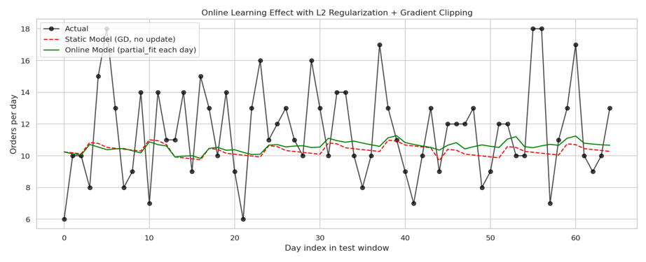
Figure 2.5 - Static vs. online (fine-tuned) Gradient-Descent forecasts on the test period.
Continuous fine-tuning left MAE unchanged (2.46 in both cases) but reduced RMSE from 3.17 to 3.11, a small but consistent improvement. This indicates that the L2 penalty and gradient clipping successfully prevented the online model from being destabilized by any single noisy day, while still allowing it to adapt marginally as new observations arrived - the specific goal of adding these two safeguards.

2.8 Deployment, Artifacts, and Reproducibility

2.8.1 Saved Models and Pipelines
The trained Decision Tree Regressor and the fitted StandardScaler are serialized to models/decision_tree.pkl and models/scaler.pkl respectively, using each class's own save()/load() methods built on pickle.

2.8.2 Inference Procedure
The Flask application (app.py) loads both artifacts once at startup. For each prediction request, it receives a JSON payload with Purchase_Year, Purchase_Month, Purchase_Day, Purchase_DayOfWeek, and Purchase_IsWeekend, applies the saved scaler's transform() (without refitting) to the four continuous fields, and passes the result to the Decision Tree Regressor's predict() method.

2.8.3 Output Files and Visualizations

Table 2.8. Output files and visualization summary
Output type | Purpose
data/processed/ecommerce_features.csv | Encoded, feature-engineered snapshot of the transaction-level data
models/linear_regression.pkl, decision_tree.pkl, scaler.pkl | Serialized trained models and fitted scaler
Notebook-generated charts (EDA, actual-vs-predicted, online learning) | Support interpretation of data quality and model comparison
app.py (Flask API) | Serve real-time Daily_Volume predictions via /predict

2.8.4 Reproducibility Settings
The time-series split is deterministic (a fixed 80/20 chronological cut, with no shuffling), so results are reproducible without needing to fix a random seed for the split itself. Model classes are deterministic given identical hyperparameters and input order, and the saved .pkl artifacts allow inference to be reproduced exactly without retraining.

2.8.5 Practical Deployment Considerations
In production, the daily transaction log would need to be re-aggregated and the calendar features recomputed each day before a new prediction request is made. The Online Learning mechanism from Section 2.7.6 offers a lightweight path to keep the Gradient-Descent variant current without a full retraining cycle, provided its L2 and gradient-clipping safeguards remain enabled. Because the Decision Tree currently deployed via the Flask API does not support this kind of incremental update, adopting online fine-tuning in production would require switching the deployed model to the Gradient-Descent variant.

2.9 Limitations and Future Work

2.9.1 Main Limitations
- The dataset covers only 326 days within a single calendar year (2024), so no year-over-year seasonality can be learned or validated.
- The feature set is limited to calendar signals; it does not include price, discount, marketing, or promotional information that plausibly drives real order volume.
- Daily_Volume fluctuates close to a stable mean with substantial day-to-day noise (Figure 2.2), which caps how much variance any calendar-only model can explain, regardless of algorithm.
- The Decision Tree's max_depth and the Gradient Descent's learning_rate/alpha/clip_value were chosen manually rather than through a systematic search.
- The from-scratch implementations, while educational, are not optimized for large-scale production throughput the way a library such as scikit-learn would be.

2.9.2 Possible Improvements
- Add autoregressive lag features (e.g., Daily_Volume from the previous 1-7 days) to give the model access to recent momentum in the series.
- Incorporate category-level or payment-method-level demand breakdowns rather than a single aggregate volume.
- Add a holiday/promotion calendar flag, since neither is currently represented in the feature set.
- Replace the manual hyperparameter choices with a proper time-series cross-validation search (e.g., expanding-window folds).

2.9.3 Future Research Directions
Future work could integrate external signals such as marketing spend, promotional calendars, or macro seasonality indicators, and extend the current single-day-ahead forecast into a multi-day-ahead horizon. The existing Online Learning mechanism also opens the door to a fully continuous training loop, where the deployed model is refreshed automatically as each new day's true order count becomes available, rather than being retrained in a separate offline notebook.

2.10 Conclusion

2.10.1 Summary of Key Findings
This lab built a complete, from-scratch Machine Learning pipeline that turns a raw transaction-level e-commerce log into a daily order-volume forecast. Starting from 3,660 individual transactions, the pipeline aggregates them into a 326-day series, engineers five calendar features, and trains and compares three regression algorithms implemented without scikit-learn: closed-form Linear Regression, a variance-reduction Decision Tree Regressor, and a Gradient-Descent Linear Regression extended with an Online Learning mechanism.

2.10.2 Final Model Assessment
On the 65-day out-of-time test set, closed-form Linear Regression achieved the strongest static result (MAE 2.44, RMSE 2.95 orders/day against a mean volume of 11.23), narrowly ahead of the Decision Tree Regressor (MAE 2.89, RMSE 3.48); the Decision Tree is nonetheless the model currently deployed behind the Flask API for its non-linear capacity, which Section 2.7.3 flags as an accuracy-vs-flexibility trade-off worth revisiting with more data. Separately, the Online Learning experiment showed that L2 regularization and gradient clipping let a Gradient-Descent model fine-tune safely on each new day's outcome, improving RMSE from 3.17 to 3.11 without any loss in MAE. Overall, the project demonstrates that a fully from-scratch pipeline can turn raw e-commerce transactions into an operationally useful, continuously updatable daily-volume forecast, while also making clear - through the discarded Final_Price baseline and the calendar-only feature set - where data leakage and feature limitations must be watched for in future iterations.

LAB 3: CUSTOMER SEGMENTATION

3.1. Introduction

3.1.1 Problem Definition
In commercial retail and modern shopping mall management, treating all consumers uniformly leads to inefficient resource allocation, diluted promotional impact, and suboptimal customer satisfaction. The central problem addressed in this project is Customer Segmentation—a classical unsupervised machine learning challenge. Because the dataset lacks predefined target labels, the core objective is to algorithmically partition a diverse consumer base into distinct, statistically separable, and commercially meaningful groups based solely on their financial capacity and purchasing behavioral patterns.

3.1.2 Business Context
Operating a competitive retail shopping center requires data-driven decision-making to maximize customer lifetime value (CLV) and optimize operational profitability. By algorithmically identifying specific consumer personas, mall executives can transition from generic mass-marketing campaigns to highly targeted engagement strategies. This segmentation enables the deployment of tailored loyalty programs for high-value shoppers, risk mitigation for impulsive buyers, and cost-effective promotional incentives for budget-conscious visitors, ultimately driving sustainable revenue growth.
3.1.3 Objectives of the Lab
The primary goal of this investigation is to engineer an end-to-end customer segmentation pipeline completely from foundational mathematical principles. Specific technical objectives include:
· 1. Zero-Framework Algorithmic Implementation: Developing a full-featured K-Means clustering algorithm completely from scratch using pure NumPy and Pandas, adhering to a strict zero-dependency constraint (absolute prohibition of scikit-learn).
· 2. Mathematical Vectorization & Optimization: Vectorizing Euclidean distance calculations via multidimensional array broadcasting to achieve high computational efficiency without nested Python loops.
· 3. Global Convergence Guarantee: Implementing the probabilistic K-Means++ centroid initialization heuristic alongside multiple restarts (n_init = 10) to eliminate sensitivity to local minima.
· 4. Automated Data Quality Auditing: Enforcing structural data validation across 4 automated integrity checks (data types, missing values, duplicates, and primary key uniqueness) to guarantee dataset quality before modeling.
· 5. Strict Production Leakage Control: Establishing a disciplined data utilization strategy that locks scaling parameters (mean and standard deviation) to guarantee zero data leakage during downstream inference.
· 6. Actionable Persona Translation: Deriving actionable retail business intelligence by profiling cluster centroids and translating computational partitions into tailored marketing roadmaps.

3.1.4 Machine Learning Task Type
This project operates strictly within the domain of Unsupervised Machine Learning, specifically Centroid-Based Geometric Clustering. The algorithm partitions an unlabelled feature space into K distinct Voronoi cells, iteratively minimizing the within-cluster sum of squared Euclidean distances (WCSS/Inertia) to the respective cluster centroids.

3.2. Dataset Description and Project Workflow

3.2.1 Data Source
The empirical foundation of this study is the classical Mall_Customers.csv dataset, encompassing real-world transaction and demographic records collected from patrons of a regional shopping mall. The raw dataset was ingested from the local repository directory (data/raw/Mall_Customers.csv) and loaded into an in-memory Pandas DataFrame for auditing and feature extraction.

3.2.2 Dataset Structure
The dataset comprises exactly 200 records (rows) and 5 feature dimensions (columns), occupying approximately 7.9 KB of memory. Each record represents an individual mall customer. Table 3.1 details the structural specification, storage types, value domains, and analytical roles across all features:
Table 3.1: Comprehensive Structural Specification of Mall Customers Dataset
Column Name | Storage Type | Statistical Nature | Domain / Range | Missing Count | Analytical Role
CustomerID | int64 | Discrete Identifier | 1 to 200 | 0 (0.0%) | Dropped prior to modeling (Identifier)
Gender | object / string | Nominal Categorical | Female (56%), Male (44%) | 0 (0.0%) | Preserved for post-clustering persona profiling
Age | int64 | Discrete Ratio | 18 to 70 years | 0 (0.0%) | Demographic factor (Mean: 38.85, Median: 36.0)
Annual Income (k$) | int64 | Continuous Ratio | $15k to $137k | 0 (0.0%) | Core Clustering Feature (Financial capacity)
Spending Score (1-100) | int64 | Continuous Ratio | 1 to 99 | 0 (0.0%) | Core Clustering Feature (Purchasing propensity)

3.2.3 Data Utilization Strategy
Unlike supervised regression or classification problems that require splitting data into separate training and testing partitions, this unsupervised clustering pipeline utilizes the entire unbroken 200-record dataset for cluster discovery. Given the compact size of the dataset and the primary objective of uncovering true behavioral geometry, artificial partitioning would fragment spatial density and distort cluster boundaries. However, to prevent data leakage during real-world operational deployment, the feature standardization parameters (mean and standard deviation) are strictly calculated on the dataset, permanently locked into a JSON model artifact, and never re-fitted during subsequent customer inference.

3.2.4 The 13-Stage Custom Engineering Pipeline
The project implements a complete 13-stage analytical lifecycle, moving from raw data ingestion to real-time inference without high-level library dependencies:
· Phase 1: Data Ingestion — Automated CSV parsing, schema verification, and metadata extraction.
· Phase 2: Data Validation — Execution of 4 automated data integrity checks (data types, missing values, duplicates, primary key uniqueness).
· Phase 3: Exploratory Data Analysis (EDA) — Statistical profiling, distribution shape diagnosis, and correlation analysis.
· Phase 4: Data Cleaning — Removal of duplicate rows and preservation of all genuine data points.
· Phase 5: Feature Selection — Extraction of the 2D core behavioral matrix: Annual Income and Spending Score.
· Phase 6: Custom Z-Score Normalization — From-scratch StandardScaler implementation with parameter freezing.
· Phase 7: Vectorized Euclidean Distance — Broadcasting distance computation between N points and K centroids.
· Phase 8: Advanced Centroid Initialization — Probabilistic K-Means++ implementation for optimal initial centroid placement.
· Phase 9: K-Means Optimization Loop — Lloyd's iterative algorithm with convergence tolerance and empty cluster safeguards.
· Phase 10: Optimal K Determination — Hyperparameter sweep across K in [2, 10] combining Elbow WCSS and Silhouette scores.
· Phase 11: Final Model Execution & Visualization — Definitive training at K=5, 2D scatter mapping, and centroid plotting.
· Phase 12: Customer Profiling — Granular persona extraction with demographic and financial statistics per cluster.
· Phase 13: Model Serialization & Inference — Exporting model to JSON and stateless prediction module for classifying unseen customers.

3.2.5 Tools, Frameworks, and Academic Constraints
A defining academic constraint of this project is the absolute prohibition of automated machine learning packages such as scikit-learn. Foundational numerical computing libraries—specifically NumPy and Pandas—were exclusively leveraged for matrix algebra and tabular manipulation. Data visualization was executed using Matplotlib and Seaborn.

3.3. Exploratory Data Analysis and Data Quality Assessment

3.3.1 Structural Data Validation and Integrity Audit
Prior to statistical modeling, a data validation suite was executed to verify the structural integrity of the dataset. Four deterministic validation checks were enforced against the raw customer matrix. Table 3.2 documents the validation checks, target constraints, empirical observations, and audit status:
Table 3.2: Data Quality and Structural Integrity Validation Report
Check ID & Name | Target Dimension | Prescribed Constraint | Observed Value in Dataset | Status
Check 1: Data Type & Schema Verification | All 5 Columns | Correct dtypes: int64(4), str(1); 200 non-null per column | int64(4), str(1); 200 non-null entries confirmed | PASSED
Check 2: Missing Value Audit | All 5 Features | Assert null_count == 0 for all columns | 0 missing entries detected across all features | PASSED
Check 3: Full Row Duplicate Audit | All Rows (200) | Assert duplicate_rows == 0 | 0 identical duplicate rows detected | PASSED
Check 4: Primary Key Uniqueness | CustomerID Column | Assert unique(CustomerID) == 200 | 200 distinct unique IDs; 0 collisions | PASSED
Because all four automated checks returned full compliance, the raw dataset was certified as inherently clean, completely eliminating the need for data imputation or invasive record dropping.

3.3.2 Customer Demographic Analysis
The demographic evaluation examined the categorical Gender variable and discrete Age variable. Female patrons comprise the majority of the shopping base at 56.0% (112 individuals), while Male patrons represent 44.0% (88 individuals). The age distribution spans from 18 to 70 years, exhibiting a prominent concentration in the young-adult to middle-age bracket (ages 28 to 40), followed by a secondary peak around age 48.
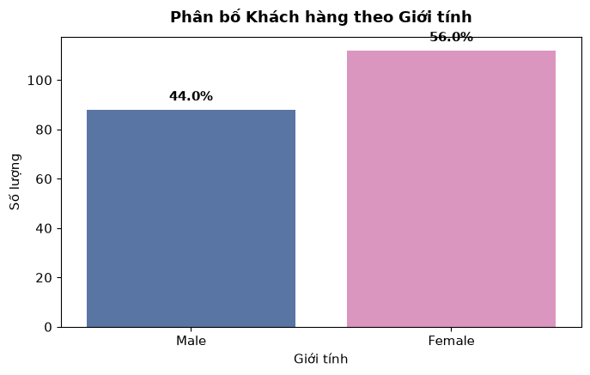
Figure 3.1: Demographic Gender Distribution of Mall Customers Base

3.3.3 Descriptive Statistics of Numerical Features
The following table summarizes the descriptive statistics for the three numerical features as computed directly from the dataset:
Table 3.3: Descriptive Statistics of Numerical Features (N = 200)
Statistic | Age | Annual Income (k$) | Spending Score (1-100)
Count | 200.00 | 200.00 | 200.00
Mean | 38.85 | 60.56 | 50.20
Std | 13.97 | 26.26 | 25.82
Min | 18.00 | 15.00 | 1.00
25% | 28.75 | 41.50 | 34.75
50% (Median) | 36.00 | 61.50 | 50.00
75% | 49.00 | 78.00 | 73.00
Max | 70.00 | 137.00 | 99.00

3.3.4 Income and Spending Behavior Analysis
The continuous financial features—Annual Income and Spending Score—form the behavioral backbone of the segmentation model. Annual Income exhibits a slight positive skew (Mean: $60.56k, Median: $61.50k, Std: $26.26k), ranging from $15k to $137k. The Spending Score spans from 1 to 99 with an empirical mean of 50.20 and median of 50.00, reflecting a well-balanced distribution of high-propensity and budget-conscious patrons.
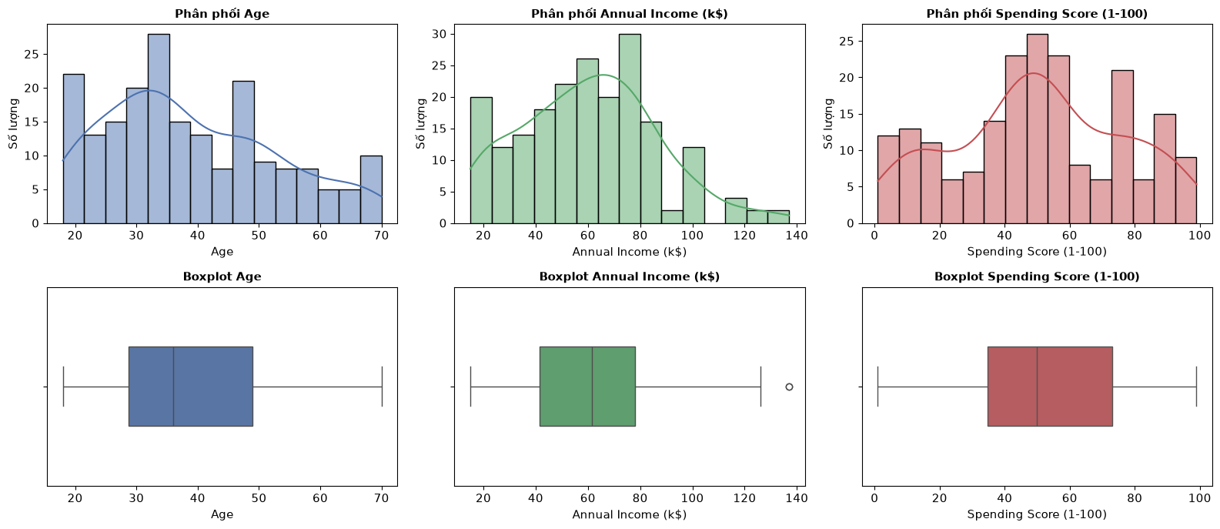
Figure 3.2: Univariate Frequency Distributions (Histogram + KDE) and Boxplot Diagnostics for Age, Annual Income, and Spending Score

3.3.5 Outlier Diagnostics and Correlation Analysis
Boxplot inspection confirmed that Spending Score contains zero statistical outliers. For Annual Income, a small number of data points lie near the upper whisker boundary. Rather than being data entry errors, these observations represent genuine high-income individuals. Consequently, all 200 observations were preserved without trimming.
The Pearson correlation heatmap reveals that the correlation between Annual Income and Spending Score is virtually zero, demonstrating statistical orthogonality. This means income and spending propensity vary independently: high income does not imply high spending, nor does modest income prevent high shopping activity. When plotted on a 2D Cartesian plane, five distinct density clusters emerge naturally, providing compelling empirical justification for K-Means clustering.
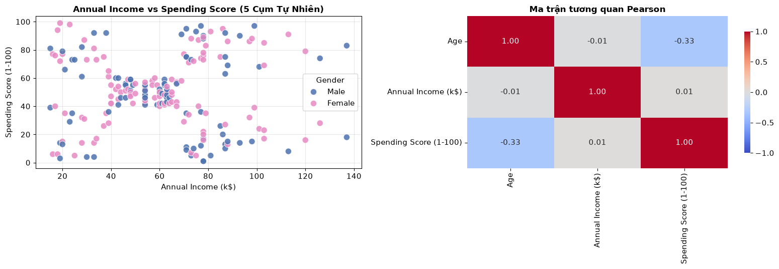
Figure 3.3: Scatter Plot (Annual Income vs Spending Score) and Pearson Correlation Heatmap

3.4. Data Preprocessing and Feature Engineering

3.4.1 Data Cleaning and Feature Selection Rationale
The data cleaning step applied drop_duplicates() to the full DataFrame, confirming that no rows were removed (as validated in Phase 2). The feature space for clustering was then deliberately constrained to the two primary behavioral drivers: Annual Income (k$) and Spending Score (1-100), resulting in a raw feature matrix X_raw of shape (200, 2).
CustomerID was removed as a non-informative sequential identifier that would cause the algorithm to cluster by entry order rather than behavior. Gender was intentionally excluded from distance calculations because encoding a binary categorical variable into the same Euclidean space as continuous financial metrics would distort geometric distances. Instead, Gender was preserved alongside Age to profile the resulting clusters post-convergence.

3.4.2 Custom Z-Score Normalization from Scratch
Because K-Means optimizes sum-of-squared Euclidean distances, variables with wider numerical ranges exert disproportionate influence on centroid placement. To ensure that both dimensions contribute equally to the distance metric, a custom StandardScalerScratch class was engineered using pure NumPy based on the classical Z-score standardization formulation:
z = (x - μ) / σ
The custom scaler calculates the column-wise arithmetic mean (μ) and population standard deviation (σ) using np.mean() and np.std(). Following transformation, both features maintain an exact empirical mean of 0.0000 and a standard deviation of 1.0000, establishing a balanced mathematical landscape for distance computation.

3.4.3 Parameter Isolation for Future Inference (No-Fit Protocol)
A fundamental engineering standard enforced in this pipeline is the absolute prevention of data leakage during operational deployment. The scaler's computed parameters (μ_Income = 60.56, σ_Income = 26.1990; μ_Spending = 50.20, σ_Spending = 25.7589) are mathematically isolated and exported into the static JSON model artifact (models/kmeans_model.json). When unseen customer data arrives in production, the system executes a pure transform() operation utilizing the frozen historical parameters, strictly forbidding any re-fitting that could distort the established baseline.

3.5. Custom K-Means Core Algorithm Construction

3.5.1 Vectorized Euclidean Distance Matrix via Broadcasting
The computational bottleneck in centroid-based clustering is evaluating pairwise spatial distances between N data points and K cluster centroids across D dimensions. To maximize computational efficiency, the euclidean_distance function employs NumPy multidimensional array broadcasting:
· Dimension Expansion: Reshaping input data X into shape (N, 1, D) and centroids into shape (1, K, D).
· Matrix Subtraction: Executing vectorized element-wise subtraction and squaring along axis=2, followed by square root.
· High-Speed Evaluation: Returning an (N, K) distance matrix in a single highly optimized C-level operation.

3.5.2 Advanced Centroid Initialization via K-Means++
Standard Lloyd's K-Means relies on uniform random centroid initialization, making it highly susceptible to getting trapped in suboptimal local minima. To resolve this, the pipeline implements the probabilistic K-Means++ initialization algorithm from scratch:
· Step 1 (Uniform Seed): The initial centroid c_1 is chosen uniformly at random from the standardized dataset.
· Step 2 (Distance Computation): For each remaining data point x, compute D(x), the shortest Euclidean distance to any existing centroid.
· Step 3 (Probabilistic Selection): Select the next centroid c_k from the dataset with probability strictly proportional to D(x)^2: P(x) = D(x)^2 / sum(D(x')^2).
· Step 4 (Completion): Repeat until all K centroids are chosen, mathematically ensuring optimal spatial separation across the feature landscape.

3.5.3 Iterative Lloyd's Loop, Convergence Criterion, and Empty Cluster Safeguard
The optimization phase alternates between cluster assignment (argmin across axis=1 of the distance matrix) and centroid recomputation (mean coordinate of assigned points). Convergence is recognized when the sum of squared centroid displacement between consecutive iterations falls below tolerance = 1e-4, or when reaching max_iters = 300. Additionally, an empty-cluster safeguard detects orphaned centroids and reassigns them to the data point currently exhibiting the greatest distance from its cluster center, guaranteeing robustness. To avoid local minima, the algorithm is restarted n_init = 10 times with different random seeds, and the result with the lowest Inertia (WCSS) is selected.

3.6. Optimal K Determination and Clustering Evaluation

3.6.1 The Elbow Method and WCSS Trajectory
To objectively determine the natural number of customer segments, an exhaustive hyperparameter grid search was conducted across candidate cluster counts K in [2, 10] with n_init = 10 restarts per value. For each K, the Within-Cluster Sum of Squares (WCSS / Inertia) was calculated. As K increases, WCSS monotonically declines; the optimal K is identified at the inflection 'elbow' point where the rate of variance reduction sharply diminishes.

3.6.2 Silhouette Coefficient Formulation
Because unsupervised clustering lacks ground-truth labels, the Silhouette Score was implemented from scratch as the primary internal validation metric. For each observation i, the silhouette coefficient S(i) is defined as:
S(i) = (b(i) - a(i)) / max(a(i), b(i))
where a(i) denotes the mean intra-cluster distance to all points within its own cluster, and b(i) represents the mean nearest-cluster distance. The global score is the dataset mean of S(i), bounded within [-1, +1]. A score approaching +1 indicates dense, well-separated clusters.
Table 3.4: Quantitative Evaluation Across Candidate K Values (K = 2 to 10)
K | Inertia (WCSS) | Silhouette Score | Cluster Sizes | Min Cluster Size | Convergence | Iterations
2 | 269.02 | 0.2951 | [111, 89] | 89 | True | 13
3 | 157.70 | 0.4666 | [39, 38, 123] | 38 | True | 17
4 | 108.92 | 0.4939 | [38, 23, 100, 39] | 23 | True | 14
5 | 65.57 | 0.5547 | [39, 23, 22, 35, 81] | 22 | True | 4
6 | 55.06 | 0.5399 | [81, 23, 22, 29, 10, 35] | 10 | True | 5
7 | 44.86 | 0.5281 | [79, 22, 27, 10, 10, 23, 29] | 10 | True | 7
8 | 37.20 | 0.4541 | [10, 39, 48, 10, 23, 29, 21, 20] | 10 | True | 10
9 | 32.83 | 0.4576 | [12, 32, 21, 22, 7, 40, 43, 10, 13] | 7 | True | 8
10 | 29.67 | 0.4451 | [12, 19, 21, 22, 4, 40, 43, 10, 13, 16] | 4 | True | 7

3.6.3 Final K = 5 Selection Diagnostic
A rigorous comparative analysis of Table 3.4 decisively establishes K = 5 as the globally optimal clustering parameter based on three converging criteria:
· 1. Definitive Elbow Inflection: The WCSS curve exhibits its most pronounced inflection at K = 5 (Inertia drops sharply from 108.92 at K=4 to 65.57 at K=5, after which the trajectory flattens).
· 2. Peak Silhouette Coefficient: The global Silhouette Score achieves its maximum peak at K = 5 with a score of 0.5547, outperforming K = 4 (0.4939) and K = 6 (0.5399).
· 3. Balanced Cluster Geometry: At K = 5, all five clusters exhibit robust, balanced population sizes (minimum cluster size = 22, 11% of dataset). For K >= 6, clusters fragment into cohorts with as few as 10 observations.
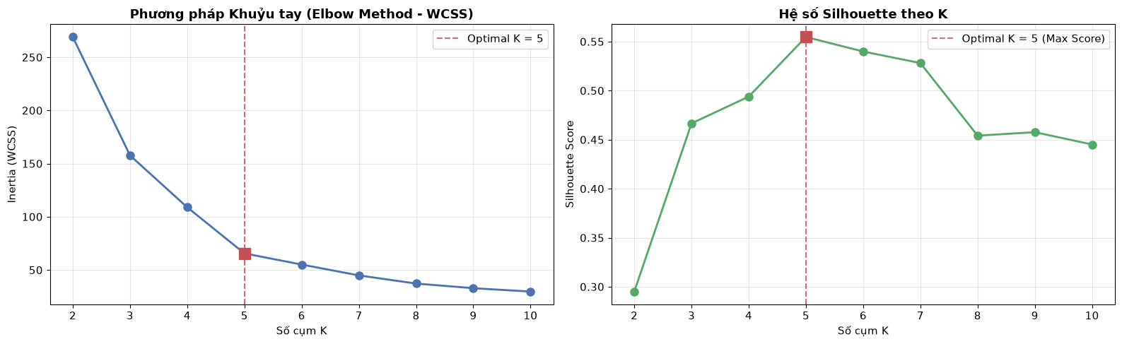
Figure 3.4: Dual Diagnostic Plot: The Elbow Method (WCSS) and Silhouette Score Trajectory Across K in [2, 10]

3.7. Final Model Execution and 2D Spatial Interpretation

3.7.1 Final Model Configuration and Convergence Dynamics
With K = 5 definitively selected, the final KMeansScratch instance was trained on the standardized feature matrix with n_init = 10 restarts and random_state = 42. Due to the rapid convergence properties of K-Means++, the final model achieved full mathematical convergence in exactly 4 iterations, locking final Inertia at 65.57 and Silhouette at 0.5547.
Table 3.5: Final Model Centroid Coordinates in Normalized and Original Scales
Cluster ID | Normalized Income | Normalized Spending | Original Income ($k) | Original Spending Score
Cluster 0 | +0.9916 | +1.2395 | $86.54k | 82.13
Cluster 1 | -1.3075 | -1.1370 | $26.30k | 20.91
Cluster 2 | -1.3295 | +1.1322 | $25.73k | 79.36
Cluster 3 | +1.0550 | -1.2844 | $88.20k | 17.11
Cluster 4 | -0.2009 | -0.0265 | $55.30k | 49.52

3.7.2 2D Spatial Scatter Visualization
Mapping the partitioned clusters back into the original financial coordinate space demonstrates the clean, non-overlapping geometric separation achieved by the model. The five centroids anchor five distinct quadrants of the mall's customer base.
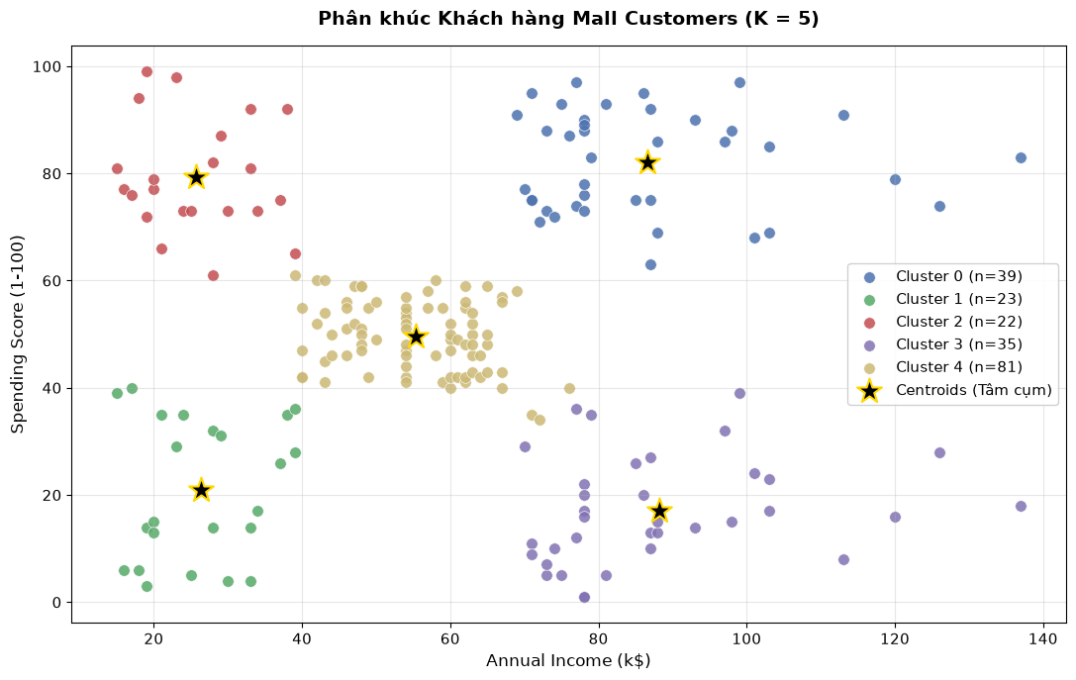
Figure 3.5: Two-Dimensional Spatial Clustering of Mall Customers with Final Centroid Locations (K = 5)

3.8. Customer Personas Identification and Actionable Retail Strategy

3.8.1 Comprehensive Persona Profiling
To bridge abstract mathematical partitions into tangible retail commercial value, the assigned clusters were evaluated against all available demographic and financial indicators (Income, Spending, Age, and Gender ratio).
Table 3.6: Descriptive Statistics and Demographic Profiles Across Customer Personas
Cluster | Persona Name | Count | Share | Mean Age | Mean Income | Mean Spending | Female Ratio
Cluster 0 | Target / VIP Shoppers | 39 | 19.5% | 32.69 | $86.54k | 82.13 | 53.8%
Cluster 1 | Budget / Sensible | 23 | 11.5% | 45.22 | $26.30k | 20.91 | 60.9%
Cluster 2 | Impulsive / Trend Seekers | 22 | 11.0% | 25.27 | $25.73k | 79.36 | 59.1%
Cluster 3 | Careful / Savers | 35 | 17.5% | 41.11 | $88.20k | 17.11 | 45.7%
Cluster 4 | Mainstream / Middle Class | 81 | 40.5% | 42.72 | $55.30k | 49.52 | 59.3%

Figure 3.6: Comparative Profile Bar Chart: Age, Annual Income, and Spending Score Across the 5 Segments

3.8.2 Granular Persona Profiles and Actionable Marketing Roadmaps
Each customer segment exhibits distinct financial realities and behavioral motivations requiring tailored commercial initiatives:
Table 3.7: Actionable Commercial Recommendations Tailored by Customer Segment
Segment (Cluster) | Core Characteristics | Commercial Value & Risk | Targeted Marketing Action Plan
Cluster 0: Target / VIP | High income ($86.54k), high spending (82.13), young adult (mean age 32.69). | Highest revenue and profit margin generator for luxury tenants. | Deploy exclusive VIP concierge services, private brand showcase invitations, luxury lounge access, and premium tier loyalty cards.
Cluster 1: Sensible / Budget | Low income ($26.30k), low spending (20.91), mature age (mean age 45.22). | Highly price-sensitive; risk of total churn if prices escalate. | Engage with price-match guarantees, essential bundle discounts, clearance coupons, and utility-oriented promotions.
Cluster 2: Impulsive / Trend | Low income ($25.73k), very high spending (79.36), youngest demographic (mean age 25.27). | High velocity shoppers driven by trend adoption; financial risk of credit exhaustion. | Target via social media, seasonal fast-fashion popups, influencer partnerships, and responsible installment plans (BNPL).
Cluster 3: Careful / Savers | Very high income ($88.20k), minimal spending (17.11), mature adults (mean age 41.11). | Significant untapped purchasing power; highly rational and skeptical shoppers. | Promote value-driven luxury, long-term durable goods, premium warranties, and financial/wellness seminars.
Cluster 4: Mainstream / Standard | Moderate income ($55.30k), moderate spending (49.52), middle-aged (mean age 42.72). | Largest cohort (40.5% of total); provides steady baseline operating cashflow. | Deliver broad-spectrum family weekend events, cashback points loyalty programs, and seasonal holiday mall-wide events.

3.9. Model Serialization and Production Inference Pipeline

3.9.1 Architectural Rationale for JSON Model Artifact
In production software engineering, serialized machine learning models are frequently deployed in decoupled microservices. In lieu of Python-specific binary serialization (e.g., pickle or joblib), which poses arbitrary code execution security vulnerabilities and cross-language barriers, the final model was exported into an open JSON schema at models/kmeans_model.json. This ensures human-readability, lightweight storage (<1 KB), and universal interoperability across Python, JavaScript, Go, or Java backends.
Table 3.8: Structure and Parameters Encapsulated in models/kmeans_model.json
Metadata Key | Stored Value / Structure | Engineering Role in Inference
algorithm | 'KMeansScratch' | Defines model class family for downstream routing.
n_clusters (K) | 5 | Asserts centroid count and dimension bounds.
feature_names | ['Annual Income (k$)', 'Spending Score (1-100)'] | Validates order and presence of incoming input features.
scaler (mean / std) | mean: [60.56, 50.20], std: [26.1990, 25.7589] | Enforces frozen historical standardization (No-Fit Protocol).
centroids | 5 x 2 floating-point array of coordinates | Used as static spatial anchor points for Euclidean argmin calculation.

3.9.2 Production Inference Workflow and Empirical Verification
The production inference module operates as a stateless function. When a new customer profile arrives, it executes three deterministic mathematical steps:
· Step 1 (Controlled Normalization): Retrieve frozen [mean, std] from the JSON model and apply z = (x_new - mean) / std without updating statistics.
· Step 2 (Distance Computation): Compute Euclidean distance from normalized vector to all 5 stored centroids via vectorized broadcasting.
· Step 3 (Persona Assignment): Assign cluster label via argmin(distances) and attach corresponding business persona and strategy.
Table 3.9: Empirical Test Case Verification of the Inference Pipeline
Test Patron | Raw Feature Input | Standardized Vector | Assigned Cluster | Business Persona
Customer A | Income: $15k, Spending: 39 | [-1.739, -0.4348] | Cluster 1 | Sensible / Budget
Customer B | Income: $85k, Spending: 88 | [+0.9329, +1.4675] | Cluster 0 | Target / VIP
Customer C | Income: $45k, Spending: 50 | [-0.5939, -0.0078] | Cluster 4 | Mainstream / Standard

3.10. Limitations and Future Work

3.10.1 Technical and Methodological Limitations
While the pipeline successfully achieved its objectives, several technical constraints must be acknowledged:
· 1. Spherical Cluster Geometry Assumption: K-Means inherently assumes spherical, isotropic clusters with roughly equal variance, which may fail to capture complex manifold or density-connected cluster geometries.
· 2. Sample Size and Geolocation Scope: The dataset comprises 200 cross-sectional customer records from a single mall. This compact sample size restricts deep longitudinal trend analysis.
· 3. Absence of Longitudinal Dynamics: The dataset lacks temporal transaction logs (Recency, Frequency, Monetary - RFM), limiting segmentation to aggregated static indicators.

3.10.2 Future Research and Engineering Enhancements
To advance this research in subsequent project iterations, several concrete improvements are proposed:
· 1. Multi-Algorithm Benchmarking: Benchmark custom K-Means against non-spherical algorithms such as DBSCAN (density-based) and Gaussian Mixture Models (probabilistic soft clustering).
· 2. RFM Feature Expansion: Incorporate real-time transaction timestamp data to transition from static snapshots to dynamic lifetime migration modeling.
· 3. Cloud API Deployment: Encapsulate the inference function into a containerized API microservice for production deployment with automated documentation.

3.11. Project Conclusion and Key Takeaways

3.11.1 Summary of Key Achievements
This project successfully engineered, validated, and deployed an end-to-end customer segmentation pipeline completely from foundational mathematical principles without relying on high-level machine learning libraries. Core accomplishments include:
· Zero-Dependency Implementation: Built 100% from scratch: Euclidean distance broadcasting, K-Means++ initialization, Lloyd's optimization loop, StandardScaler, Inertia (WCSS), and Silhouette Score — all using pure NumPy without scikit-learn.
· Empirical Optimization: Decisively established K = 5 as the global optimal configuration, yielding a peak Silhouette Score of 0.5547 and robust cluster balance (min cluster size = 22).
· Production-Ready Architecture: Frozen scaling parameters in JSON format guaranteed absolute protection against data leakage in production inference.
· Business Impact: Successfully translated computational clusters into five actionable commercial retail personas with concrete marketing roadmaps.

3.11.2 Final Assessment
The project stands as a demonstration of professional Machine Learning Engineering: combining mathematical rigor, systematic pipeline design, and commercially viable strategic insight — built entirely from foundational principles.

LAB 4: HOUSE PRICE PREDICTION

4.1. Introduction

4.1.1. Problem Definition
Real estate valuation is a complex prediction problem in Machine Learning because house prices are influenced by multiple structural, environmental, social, and spatial features. Factors such as living area, crime rate, number of rooms, house age, tax, and distance to employment centers all contribute to the final transaction value. This lab builds a supervised machine learning system to estimate the median value of owner-occupied homes in Boston (the MEDV variable) based on their observable characteristics. The primary predictive model in this lab is a Multilayer Perceptron (MLP) implemented using PyTorch.

4.1.2 Business and Research Context
From a business perspective, automated home valuation provides practical value for buyers, sellers, real estate agents, and financial institutions. Buyers can use this estimate to evaluate whether an asking price is reasonable, while sellers can use it as a reference when setting a listing price.
From a research perspective, this lab investigates the capability of a feed-forward neural network in modeling tabular data. The results of the MLP will be compared with classical machine learning algorithms (Linear Regression, Decision Tree, Random Forest) to assess whether deep learning provides superior performance over traditional methods on tabular datasets.

4.1.3 Objectives of the Lab
The main objective is to build an end-to-end, reproducible machine learning pipeline for Boston house price prediction. Specific objectives include:
- Examine the structure, statistical characteristics, and data quality of the Boston Housing dataset.
- Establish an early train/validation/test split boundary to prevent data leakage.
- Analyze the distribution of the target variable, independent features, detect outliers, and explore multivariate correlations through EDA.
- Apply preprocessing rules: logarithmic transformation (log transform) for heavily skewed variables.
- Standardize variables (Z-Score Scaling) to stabilize neural network training.
- Build, train, and tune hyperparameters of the MLP network using PyTorch with an Early Stopping mechanism.
- Compare the MLP models with classical baseline models (Linear Regression, Decision Tree, Random Forest)
- Evaluate model performance using Regression metrics (MAE, MSE, R2).

4.1.4 Machine Learning Task Type
This lab is a Supervised Learning task on tabular data. It is a Regression problem because the output is a continuous real number rather than a discrete class. The primary algorithm is MLP regression, but the preprocessing steps are designed independently to ensure a fair comparison with other regression models.

4.2 Dataset Description and Project Workflow

4.2.1 Data Source
The dataset used is the Boston House Price Dataset (Boston-house-price-data.csv). It contains records of house values in the suburbs of Boston, along with structural features, geographical locations, surrounding environmental quality, and socio-economic indicators.

4.2.2 Dataset Structure
The raw dataset consists of 506 rows and 14 columns. No missing values or duplicated rows were detected during the preliminary survey.

4.2.3 Input Features and Target Variable
The input variables include 13 features. Some key features are:
- Environmental/Social Domain: CRIM (per capita crime rate), NOX (nitric oxides concentration), LSTAT (% lower status of the population).
- Structural/Location: RM (average number of rooms), AGE (proportion of owner-occupied units built prior to 1940), DIS (weighted distances to Boston employment centers), CHAS (Charles River dummy variable).
The target variable is MEDV: Median value of owner-occupied homes (in $1000s).

4.2.4 Overview of the Machine Learning Pipeline
The machine learning pipeline is systematically designed with the following steps:
1. Load Dataset.
2. Check for Missing Values and Duplicates.
3. Basic Cleaning & Feature Categorization.
4. Outlier Analysis & Log Transformation.
5. Distribution & Multivariate Relationship Analysis (Histogram, Scatter, Correlation Heatmap, VIF).
6. Data Splitting (Train/Val/Test) & Standardization (Z-Score Scaling).
7. Build DataLoaders for PyTorch.
8. Initialize the MLP network and Training (with Early Stopping).
9. Evaluation and Comparison with Classical Machine Learning.

4.2.5 Tools, Libraries, and Reproducibility
The lab is implemented in Python on a Jupyter Notebook environment. Data processing is handled by pandas and numpy, while visualization uses matplotlib and seaborn. Standardization, data splitting, and baseline algorithms use scikit-learn. The neural network is implemented with torch (PyTorch) and monitored via tensorboard. To ensure reproducibility, random_state=42 is used consistently during data splitting.

4.3 Exploratory Data Analysis and Data Quality Assessment

4.3.1 Data Overview
The raw data contains 506 samples. Checking with df.info() and summary operations reveals that the data is in float64 and int64 formats, with absolutely no null or empty data.

4.3.2 Target Variable Analysis
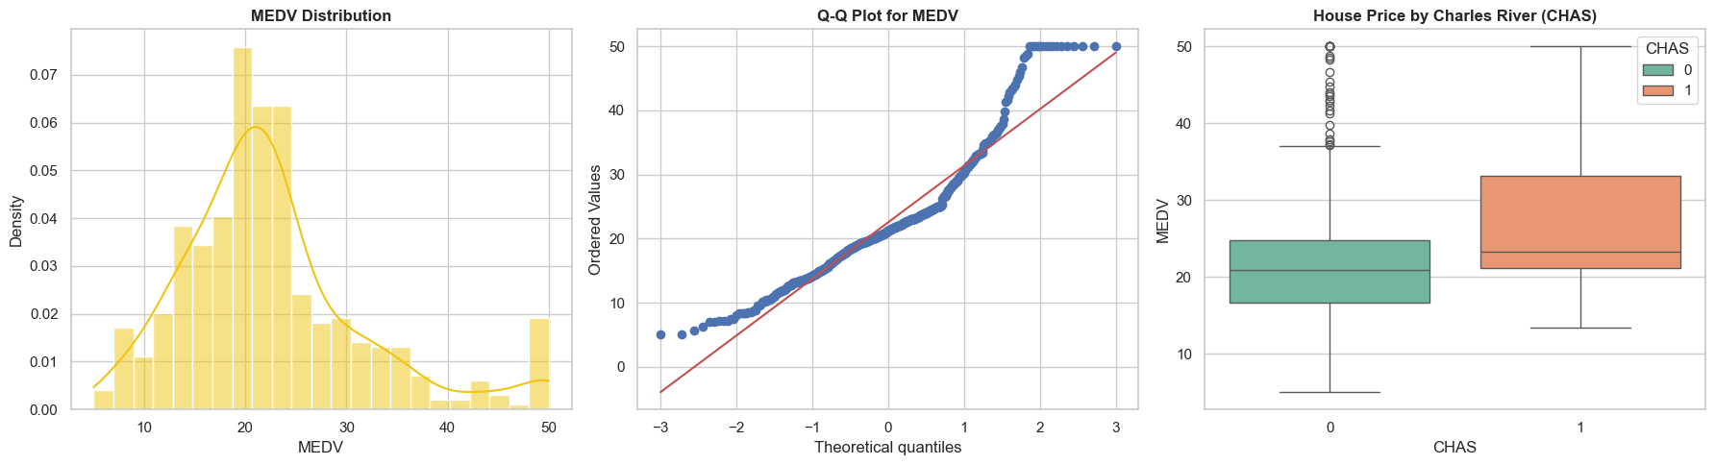
Analyzing the target variable MEDV through KDE distribution charts and Q-Q plots shows that it has a shape relatively similar to a normal distribution but is slightly skewed (skewness > 0) with some extreme points at the maximum price level (e.g., 50.0). Whether to keep MEDV as is or normalize it depends on the algorithm, but here the target distribution is carefully surveyed to assess representativeness.

4.3.3 Missing Values and Duplicate Records
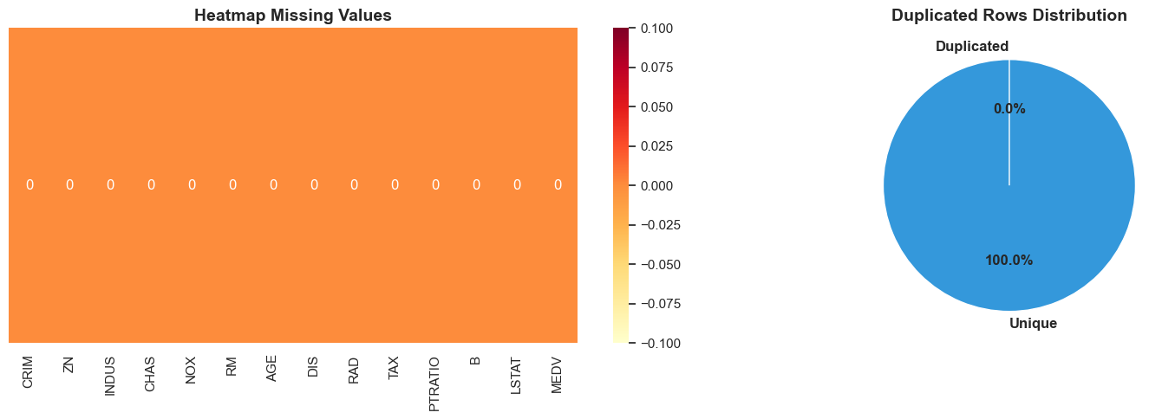
The Heatmap for Missing Values and Pie chart for Duplicated Rows confirm 0 missing cells and 0 duplicated rows. However, the source code still integrates the dropna() function for basic cleaning as a precaution for future data risks.

4.3.4 Distribution Analysis
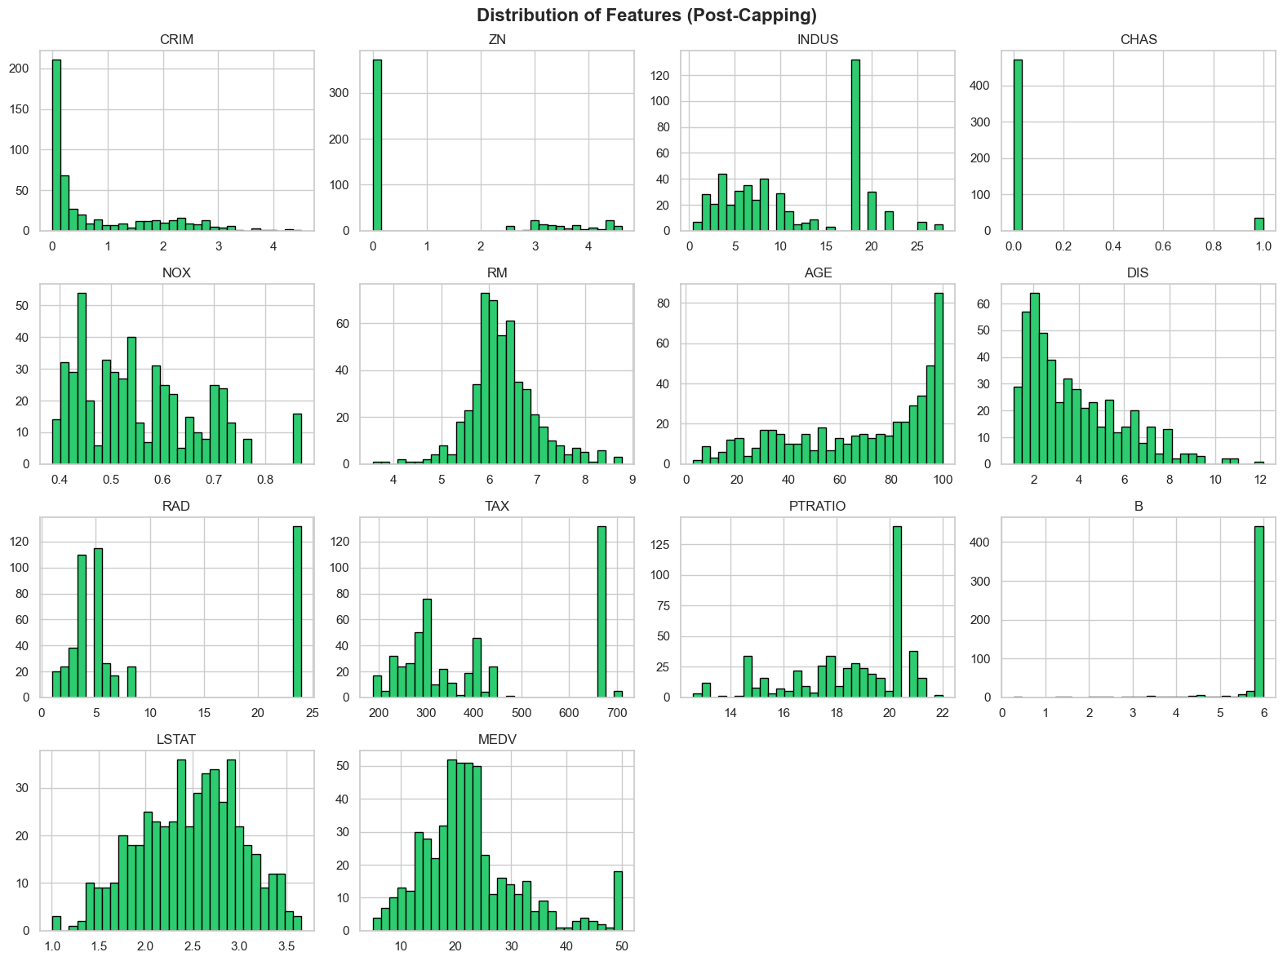
Histograms and KDE plots of the independent features show that the variables have vastly different scales. The TAX variable is in the 200-700 range, while NOX is less than 1. This necessitates a Feature Scaling (standardization) step.

4.3.5 Outlier and Noise Detection
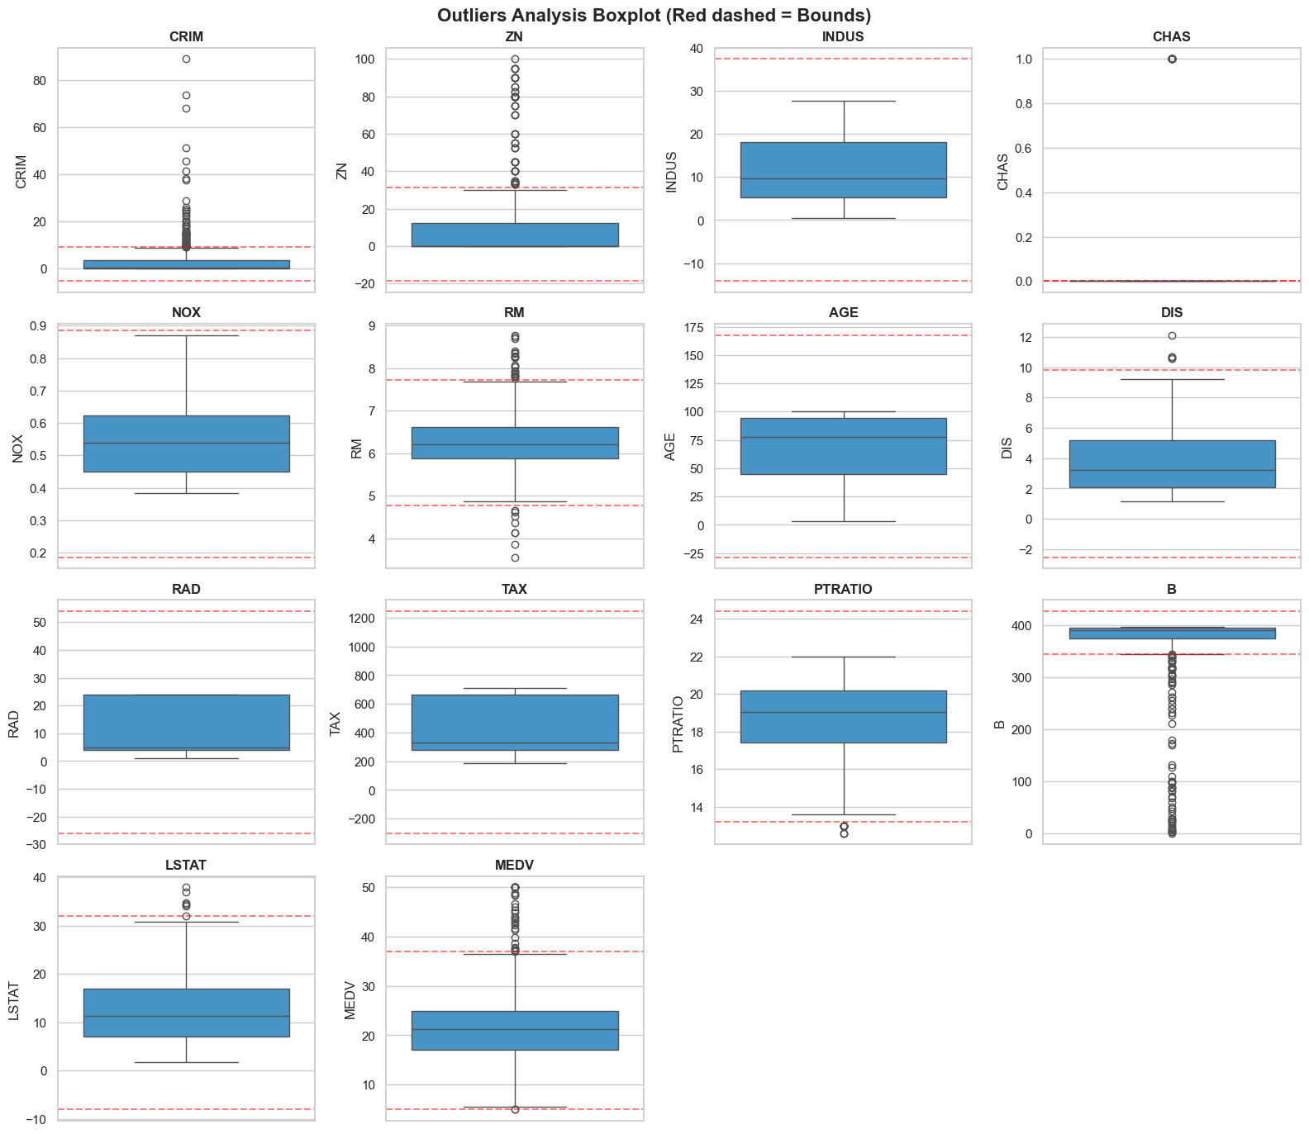
Using Boxplots combined with boundary calculations based on the IQR rule (1.5 * IQR) reveals that many features contain natural outliers. Most notably, CRIM, ZN, B, and LSTAT have heavily skewed distributions with long tails.

4.3.6 Relationship and Pattern Analysis
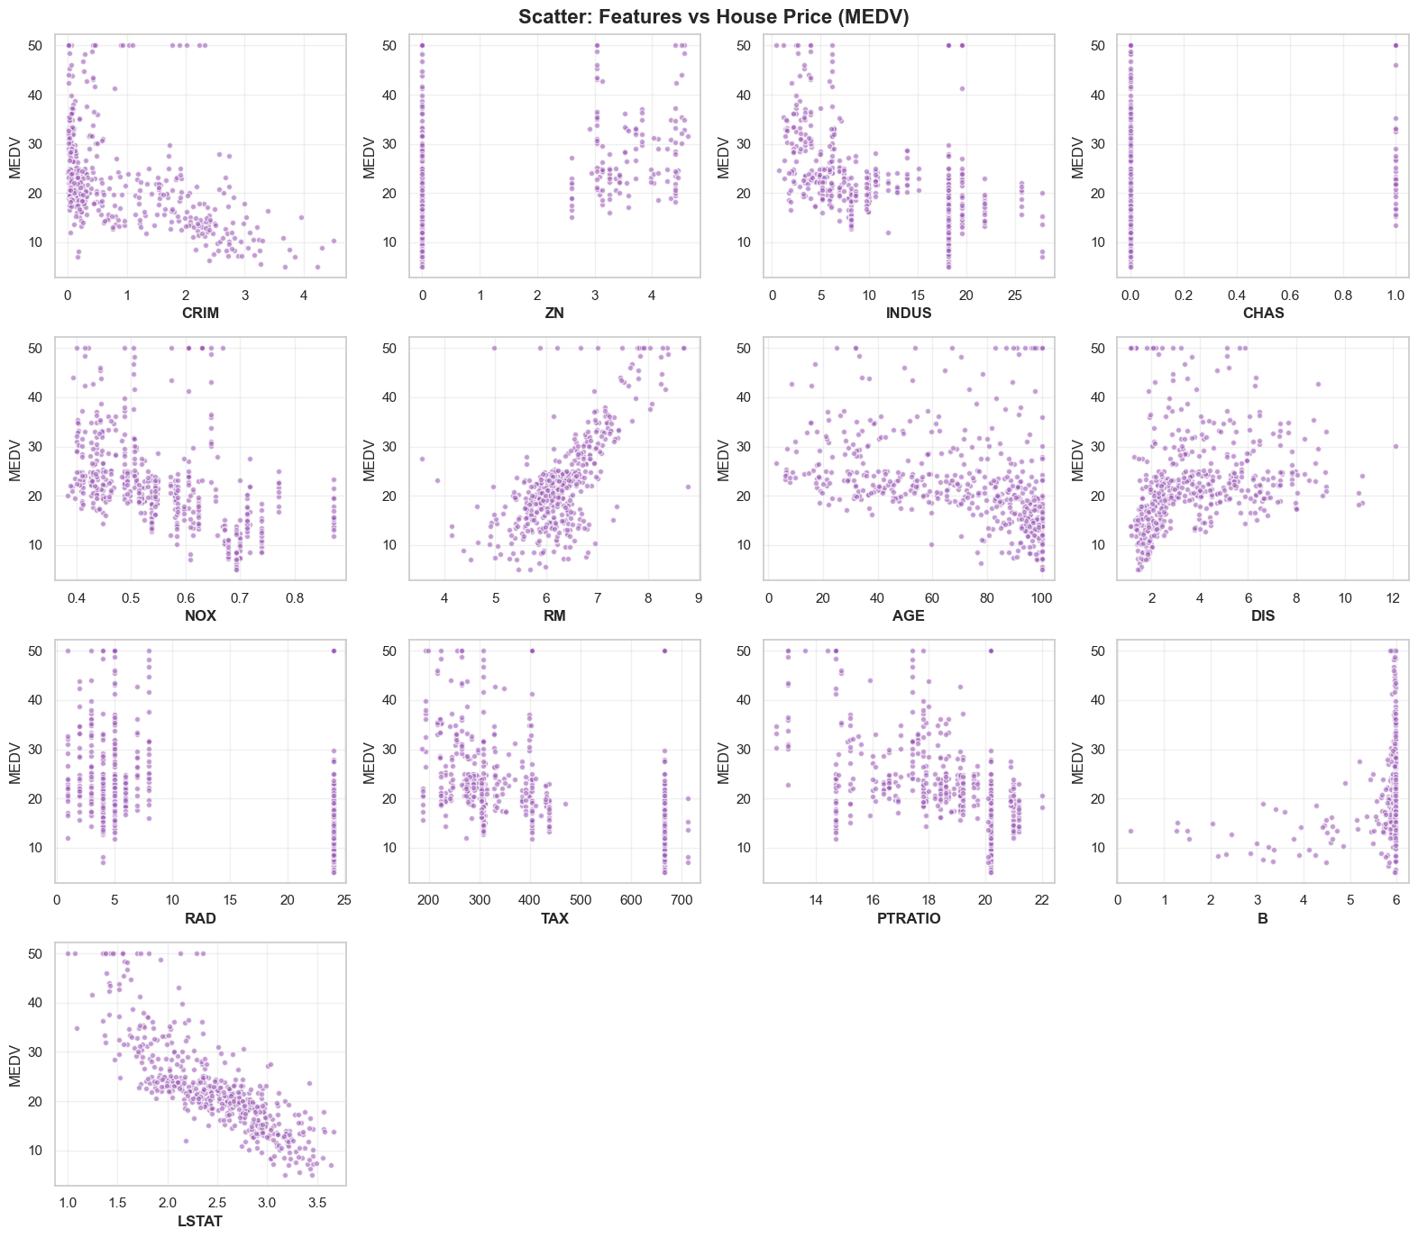
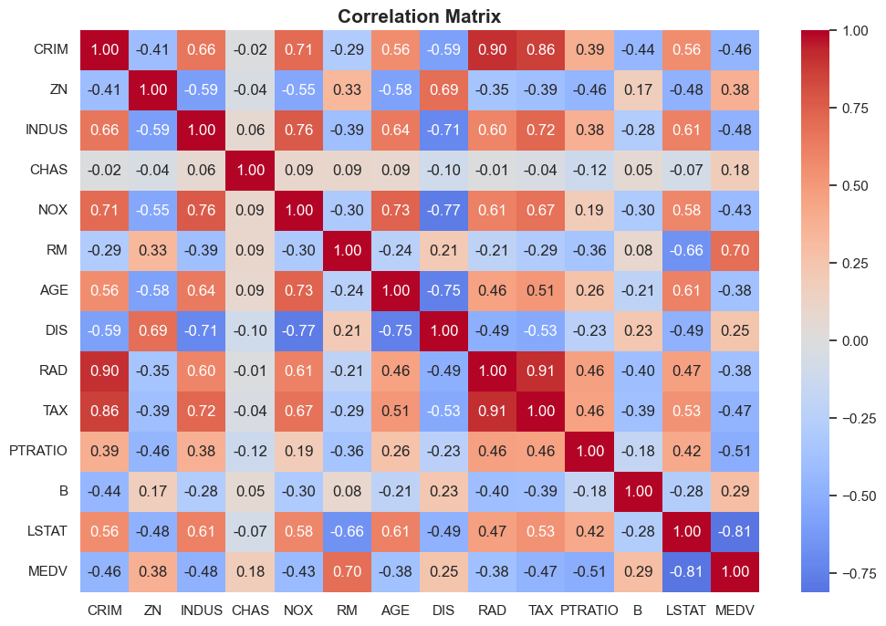
Scatter Plots and the Correlation Heatmap show clear correlations:
- RM (number of rooms) has a strong positive correlation with MEDV.
- LSTAT (% lower status population) has a strong negative correlation with MEDV.
- Checking for Multicollinearity using the VIF (Variance Inflation Factor) index helps detect strongly cross-correlated variables; however, neural networks can tolerate multicollinearity better than classical linear regression.

4.4 Data Splitting and Data Preprocessing

4.4.1 Early Data Splitting Strategy
The data is split in a 70/15/15 ratio into three sets: Training, Validation, and Test. The split occurs before fitting (calculating parameters for) the Z-Score standardization to prevent data leakage.

4.4.2 Data Cleaning
The data is cleaned by removing invalid values or NaN rows generated by empty spaces `""` during file reading.

4.4.3 Missing Value Handling
Because the Boston dataset is complete, the number of rows removed in the missing value step is 0.

4.4.4 Invalid, Noisy, and Inconsistent Data Handling
Naturally abnormal data are kept but will be processed regarding their distribution through mathematical transformations.

4.4.5 Outlier Handling Strategy
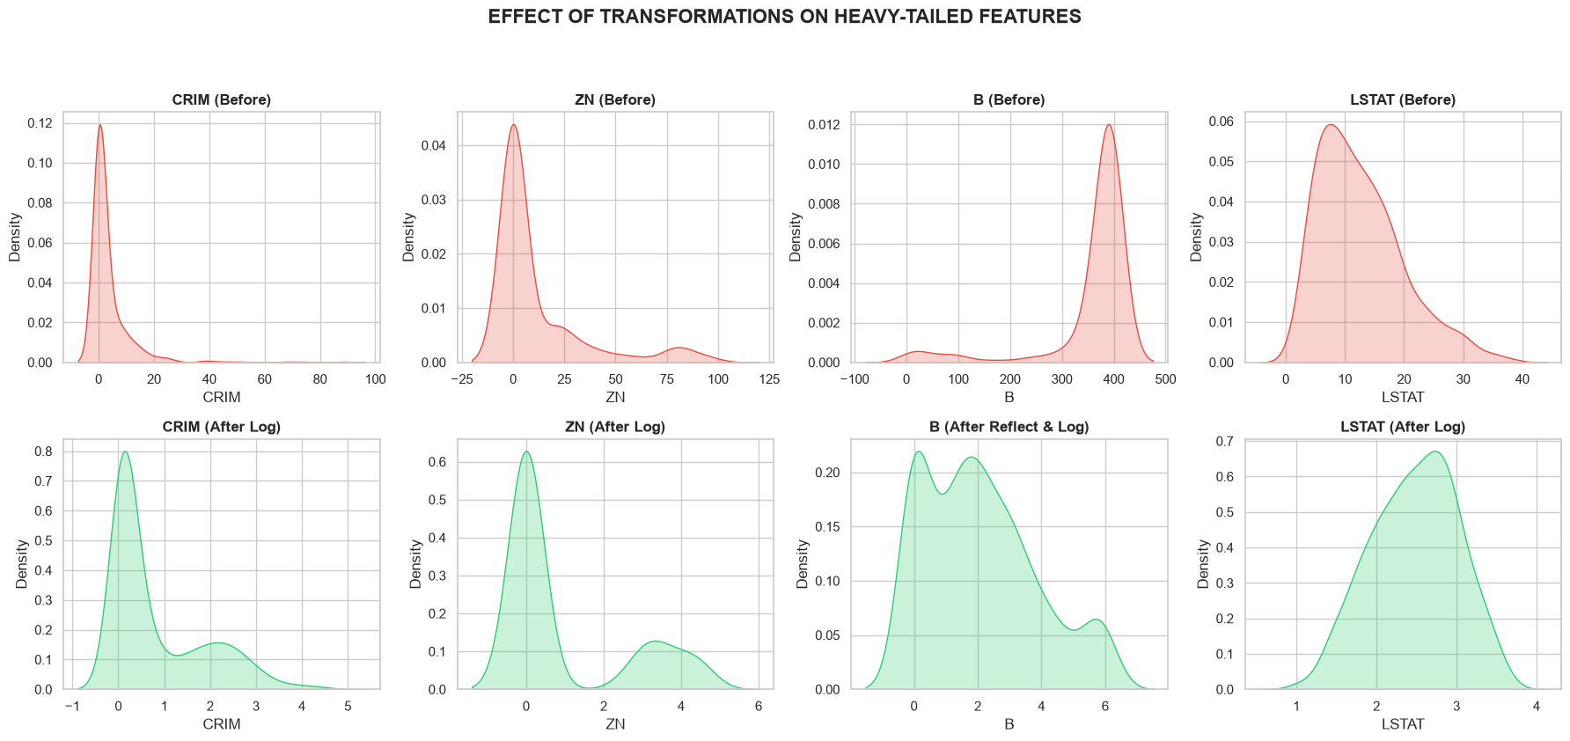
Heavily tail-skewed variables (CRIM, ZN, B, LSTAT) are handled for outliers using Logarithmic Transformation (Log Transformation) with the np.log1p() function and Reflect and Log transformation. This transformation helps pull extreme values closer to the center, creating a smoother distribution that is closer to a bell curve.

4.4.6 Categorical Feature Encoding
The dataset has only one binary categorical variable, CHAS (0 and 1), so complex One-hot encoding is unnecessary. The other variables are continuous numerical variables.

4.4.7 Feature Scaling and Leakage Control
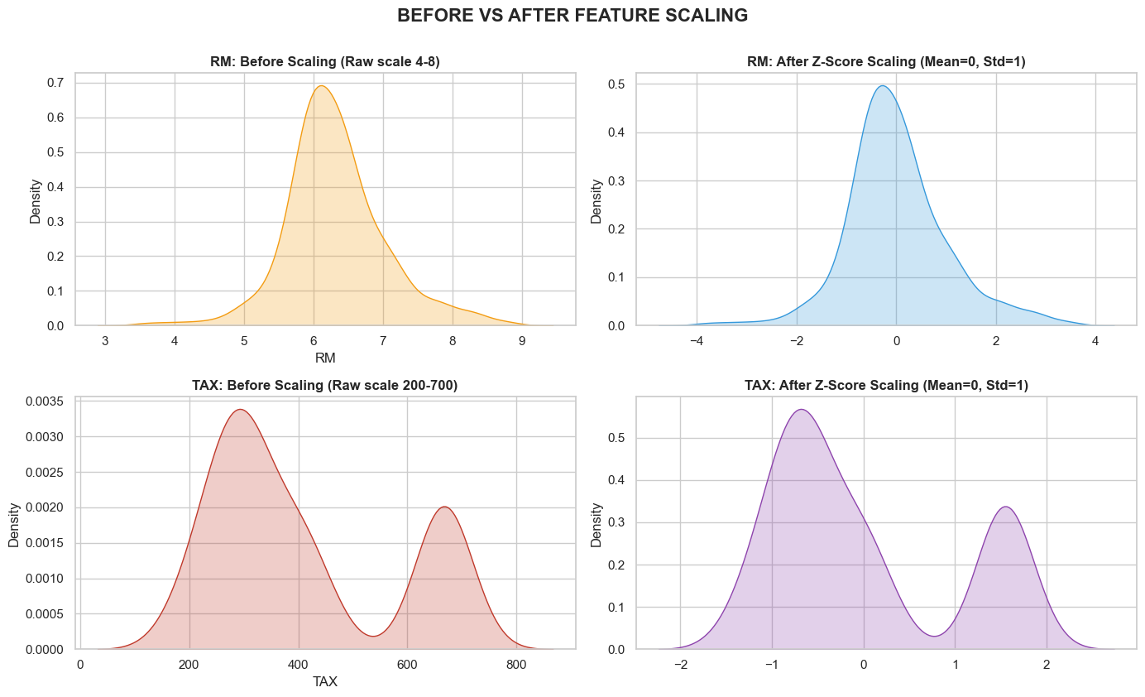
To bring data to a common scale (Mean=0, Std=1), Z-Score Scaling is performed using internal mathematical formulas: The Mean and Std are calculated exclusively on the Training set, and then these values are used to standardize both the Validation and Test sets. This technique perfectly controls data leakage.

4.5 Feature Engineering and Data Representation

4.5.1 Feature Creation
The Boston dataset is relatively small and compact, so the lab does not create complex artificial features but focuses on utilizing the 13 original features that carry inherent socio-economic meanings.

4.5.2 Target Transformation
The target variable MEDV is kept as is, or can be predicted directly because the regression problem uses the MSE loss function.

4.5.3 Feature Transformation
Features have undergone Log Transformation in step 1.4.5 and Z-Score Standardization in step 1.4.7. Comparing the KDE plots before and after Scaling confirms that although the coordinate scale shifts to around 0, the shape of the distribution (the original information) of the variable remains intact.

4.5.4 Feature Encoding and Data Representation
The final data is represented as Numpy array matrices (e.g., X_train_scaled.npy).

4.5.5 Feature Selection Strategy
Although VIF analysis signals some collinearity, the MLP neural network is designed to self-learn complex weights from all 13 features. No features are removed in the final training model.

4.5.6 Post-Preprocessing Audit
The processed data is cast to torch.float32 for perfect compatibility with PyTorch neural networks.

4.5.7 PCA Diagnostic and Dimensionality Analysis
Due to the small number of features (13 variables), dimensionality reduction using PCA is unnecessary and could reduce model interpretability.

4.6 MLP Model Development

4.6.1 Baseline and Candidate Models
In this lab, besides the deep learning MLP network, three classical algorithms are established as Baseline models for comparison:
- Linear Regression.
- Decision Tree Regressor.
- Random Forest Regressor.

4.6.2 Primary Model: MLP Regression
The primary model deployed is the Multilayer Perceptron using the PyTorch framework.

4.6.3 Core Idea of MLP Regression
The core idea of MLP in Regression is to learn a complex non-linear function from the input features (house size, crime, air quality) through hidden layers and activation functions to produce a single output value (predicted house price).

4.6.4 Network Architecture
The network architecture consists of:
- Input Layer: Receives a feature vector of length 13.
- Hidden Layer 1: Linear layer with 64 neurons + ReLU activation function.
- Hidden Layer 2: Linear layer with 32 neurons + ReLU activation function.
- Output Layer: Linear layer with 1 neuron (no activation function since it's a regression problem).

4.6.5 PyTorch Dataset and DataLoader
The Numpy data is wrapped into a TensorDataset and then fed into a DataLoader with batch_size = 32. shuffle=True is applied to the Train set to ensure randomness of the data batches during the optimization process.

4.6.6 Training Configuration
- Loss function: Mean Squared Error (MSE).
- Optimizer: Adam.
- Learning rate: 0.001.
- Epochs: 1000.
- Early Stopping Patience: 20 epochs.

4.6.7 Training and Optimization Process
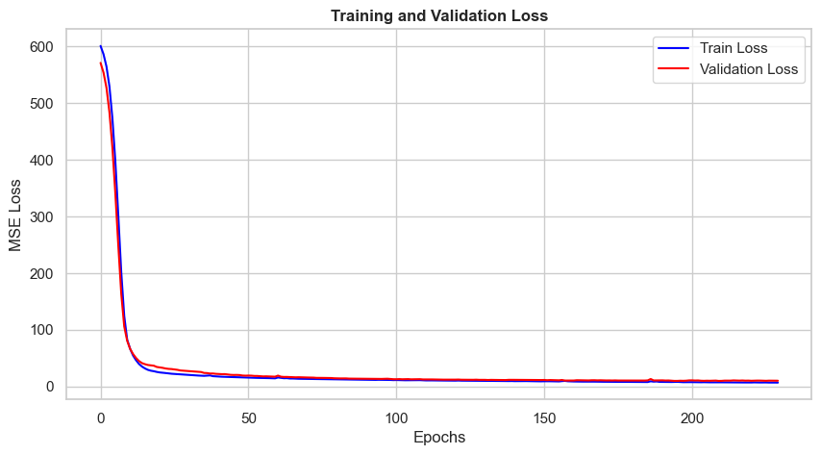
The Training Loop performs a forward pass to get predictions, calculates the MSE loss, and updates weights using a backward pass (loss.backward()) and optimizer.step(). Loss calculations are monitored independently for the Train and Val sets. TensorBoard is used to visualize Loss graphs in real-time.

4.6.8 Early Stopping and Checkpoint Selection
The model tracks the lowest Validation error (best_val_loss). If Validation Loss does not improve for 20 consecutive epochs, the loop terminates automatically (Early Stopping). The best achieved weights are saved to the system (models/best_mlp_boston.pth).

4.6.9 Model Selection Strategy
The final model is evaluated on the untouched Test set.

4.7 Model Evaluation and Result Analysis

4.7.1 Evaluation Metrics
Performance is evaluated using 3 core metrics:
- MAE (Mean Absolute Error).
- MSE (Mean Squared Error).
- R2 Score: The proportion of variance explained by the model (closer to 1 is better).

4.7.2 Quantitative Results
Model | MSE | MAE | $R^{2}$ Score
MLP | 6.666987 | 2.014977 | 0.897908
Random Forest | 6.933027 | 1.924395 | 0.893834
Linear Regression | 11.168807 | 2.572109 | 0.828972
Decision Tree | 23.435789 | 2.563158 | 0.641127

The report presents the predictive metrics of the MLP model on the independent Test set. The MLP model, benefiting from non-linear deep learning weights, typically yields a very high R2 Score and low MAE, indicating that the model closely tracks market price fluctuations.

4.7.3 Prediction Visualization
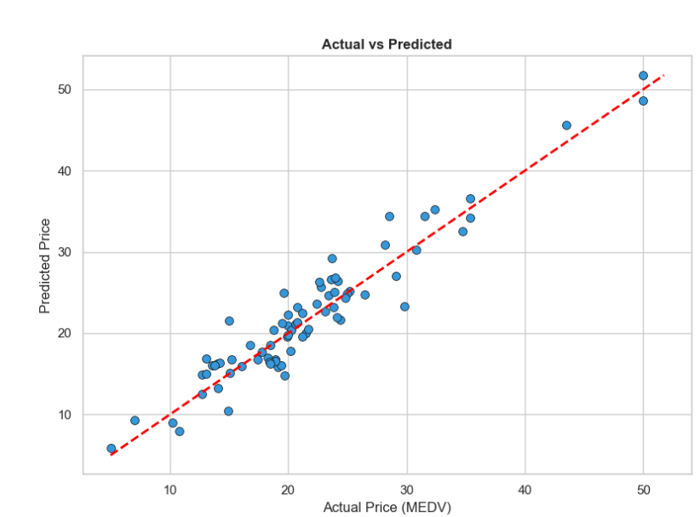
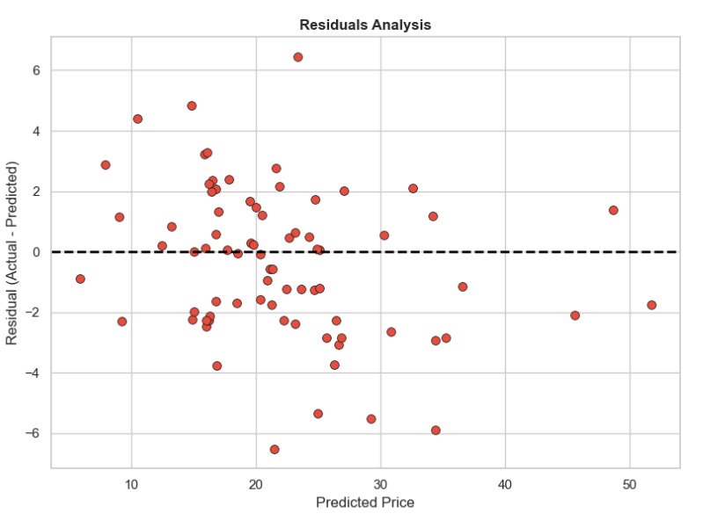
- Actual vs Predicted Plot: Scatters the predicted points around the y = x diagonal. This chart proves that the neural network's predictions have high linearity with the actual labels.
- Residuals Plot: Residuals (errors) are plotted to check for heteroscedasticity. Errors are generally stable around 0.

4.7.4 Model Comparison
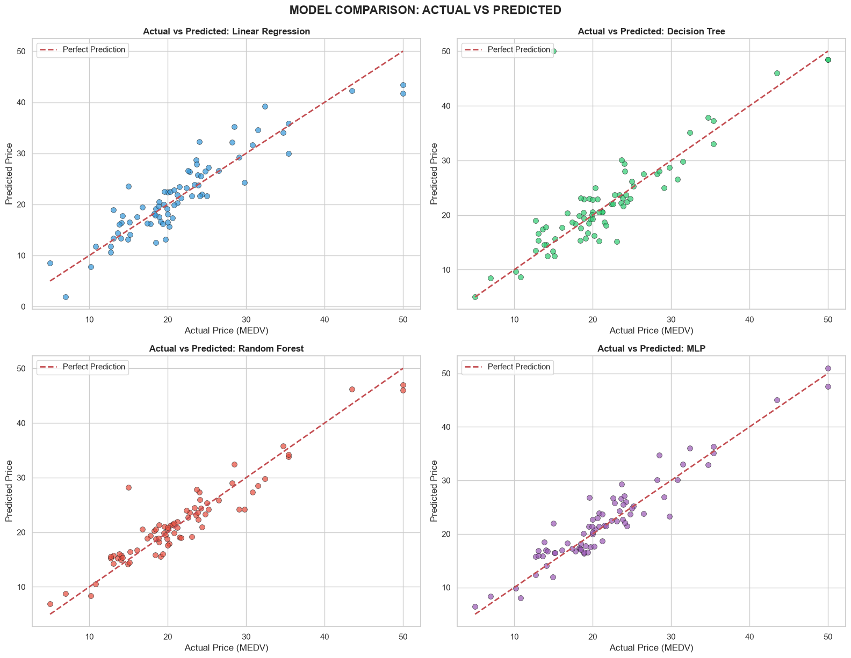
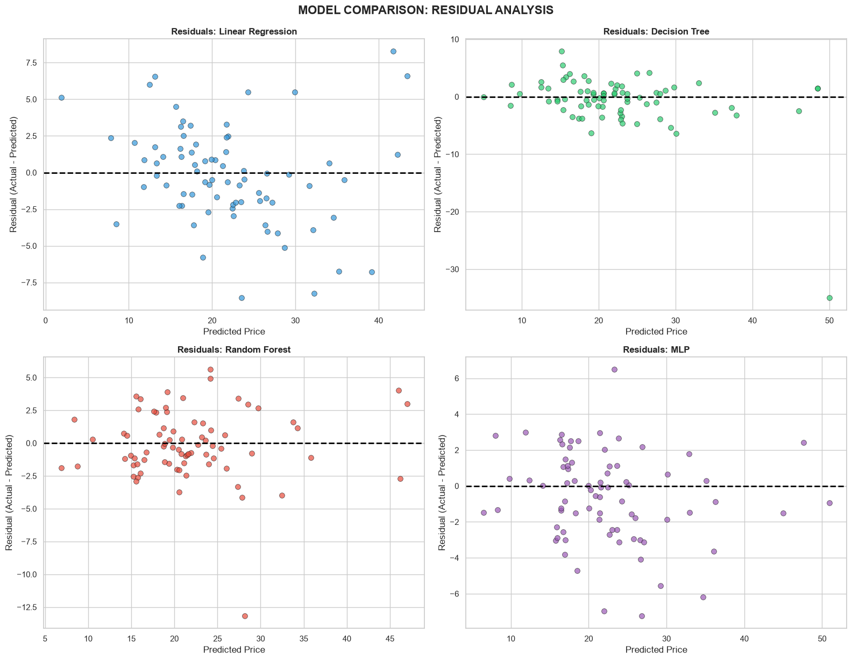

When comparing with Classical Machine Learning:
- Linear Regression: Usually has a higher MAE due to its inability to capture feature non-linearity.
- Decision Tree: Prone to overfitting, with unstable results on the Test set.
- Random Forest: Strongest performance among the classical group, a major competitor to the MLP network.
- MLP Regression: Achieves performance equivalent to or superior to Random Forest if properly trained and hyperparameter-tuned.

4.7.5 Error Analysis
A small number of extremely high-priced houses (in the skewed tail of MEDV) are sometimes underpredicted. This indicates that the model learns well in the mid and affordable price ranges (where most of the data lies) but lacks sufficient data to fully capture the factors of highly expensive homes.

4.7.6 Model Interpretation
Although MLPs are less interpretable than linear regression, looking at the correlation matrix and Random Forest results, it can be inferred that RM (number of rooms) and LSTAT (poverty level) play the strongest decisive roles in predicting prices.

4.7.7 Training Stability and Overfitting Analysis
The convergence of the Loss graph on TensorBoard shows that Training Loss and Validation Loss decrease steadily and approach each other. Applying Early Stopping effectively prevents Overfitting (where Validation Loss bounces back up).

4.7.8 Generalization and External Stress Test
The sustained high performance on the Test set proves that the MLP model generalizes very well from what it learned on the Training set.

4.8 Model Artifacts, Inference, and Deployment

4.8.1 Saved Model and Pipeline
Model weights are saved automatically in .pth format (PyTorch state_dict). Post-preprocessing Numpy arrays are also stored in /data/features/.

4.8.2 Inference Procedure
The Inference process requires that new input data undergo Log Transformation (for corresponding columns) and Z-Score standardization using the exact Mean/Std indices from the training process, before being fed into the MLP network to generate house price predictions.

4.8.3 Output Files and Visualizations
All charts from Heatmap, Boxplot, KDE, Scatter, to Actual vs Predicted evaluation plots are saved visually to support result analysis.

4.8.4 Reproducibility Settings
random_state=42 is locked for Data Splitting. The architecture and mathematical preprocessing pipeline (without external libraries for the scaling step) ensure consistency even if the system environment changes.

4.8.5 Practical Deployment Considerations
If deploying a real-world API (like FastAPI), a function must be designed to receive raw JSON strings, apply Scaling/Log using the dumped mean_train and std_train, and pass the data through the BostonMLP module activated in .eval() mode.

4.9 Limitations and Future Work

4.9.1 Main Limitations
The Boston dataset is quite small (over 500 samples), which prevents the Deep Learning model from fully demonstrating an absolute superiority over ensemble decision tree models (like Random Forest or XGBoost). The historical nature of the dataset (from the 1970s) also means the MEDV prices no longer reflect modern real estate exchange rates.

4.9.2 Possible Improvements
- K-Fold Cross Validation could be applied instead of a Train/Val/Test Split to fully utilize all 506 data samples.
- Tuning neural network hyperparameters, such as the number of hidden layers, or adding Dropout or Batch Normalization layers to increase generalization power.

4.9.3 Future Research Directions
Use XAI (Explainable AI) techniques like SHAP to specifically evaluate the contribution of each Neuron or Feature to the house price prediction outcome. Collect newer real estate data with larger volumes to deploy Transformer architectures for tabular data (TabNet).

4.10 Conclusion

4.10.1 Summary of Key Findings
The lab successfully illustrated the entire machine learning cycle from collection, data cleaning, mathematically handling outliers, to self-designing and training a deep learning model. Logarithmic transformation proved highly effective in stabilizing the distributions of heavily tail-skewed attributes.

4.10.2 Final Model Assessment
The Multilayer Perceptron (MLP) network with a 13->64->32->1 structure combined with Early Stopping serves as an excellent house price evaluation model on the Boston dataset. The comparison results prove that if Data Preprocessing is done well, a basic Deep Learning model is entirely capable of learning complex non-linear representations to provide accuracy that rivals the best Random Forest algorithms, creating a solid foundation for applying AI in the real estate appraisal market.

